Tour ID: 98112  
Tour Name: 5 Days Land of Northern Lights

Tour destinations: ['Reykjavik', 'Reykjanesviti', 'Gunnuhver', 'Blue Lagoon', 'Hella', 'Seljaland', 'Eyjafjallajokull', 'Skogafoss', 'Solheimajokull', 'Reynisfjara', 'Vik', 'Geysir', 'Gullfoss', 'Thingvellir National Park']

Tour destinations images:

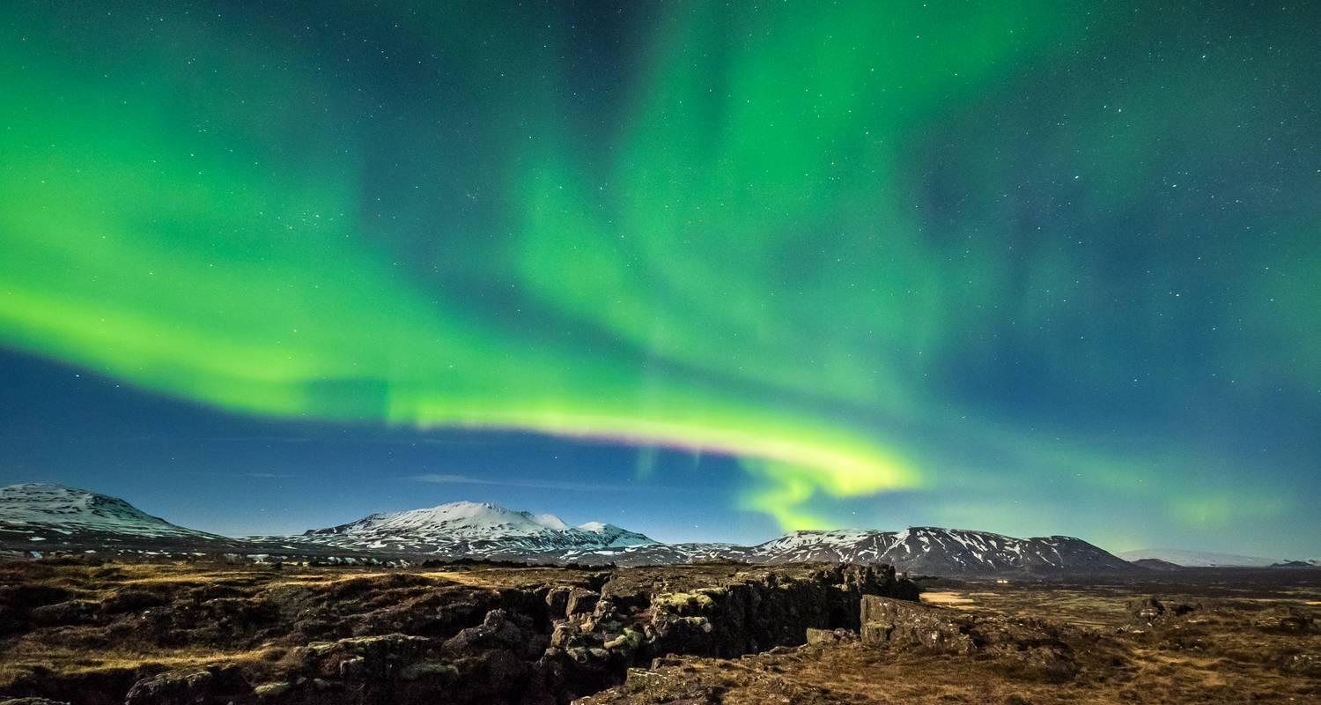

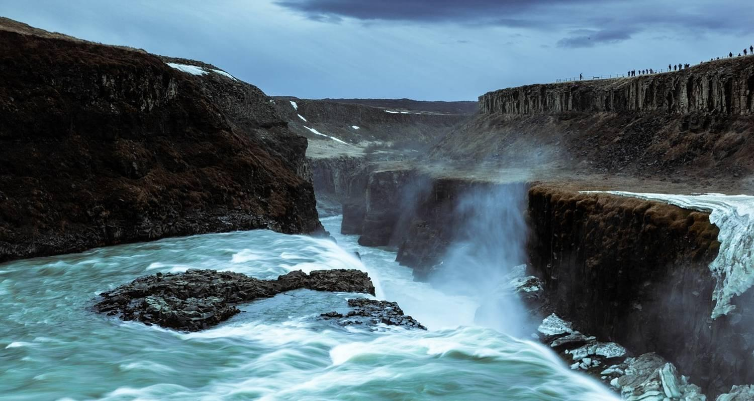

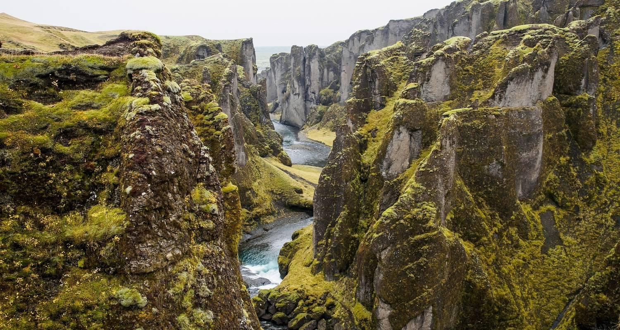

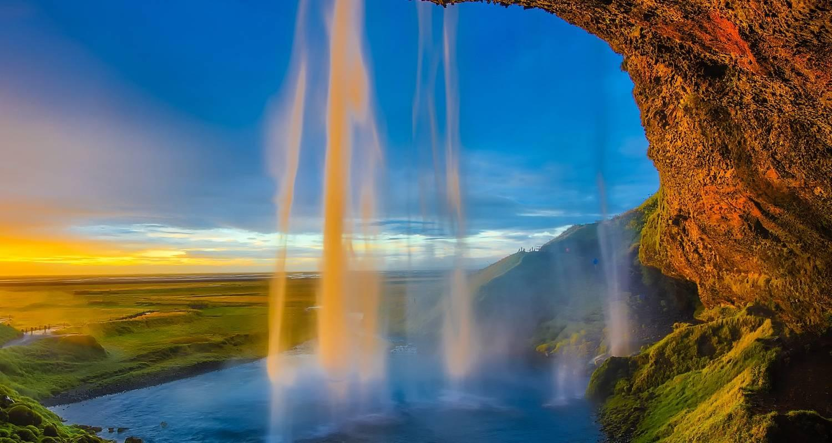

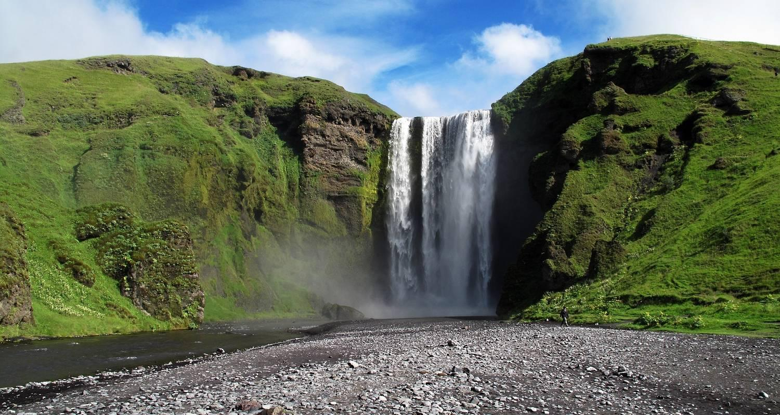

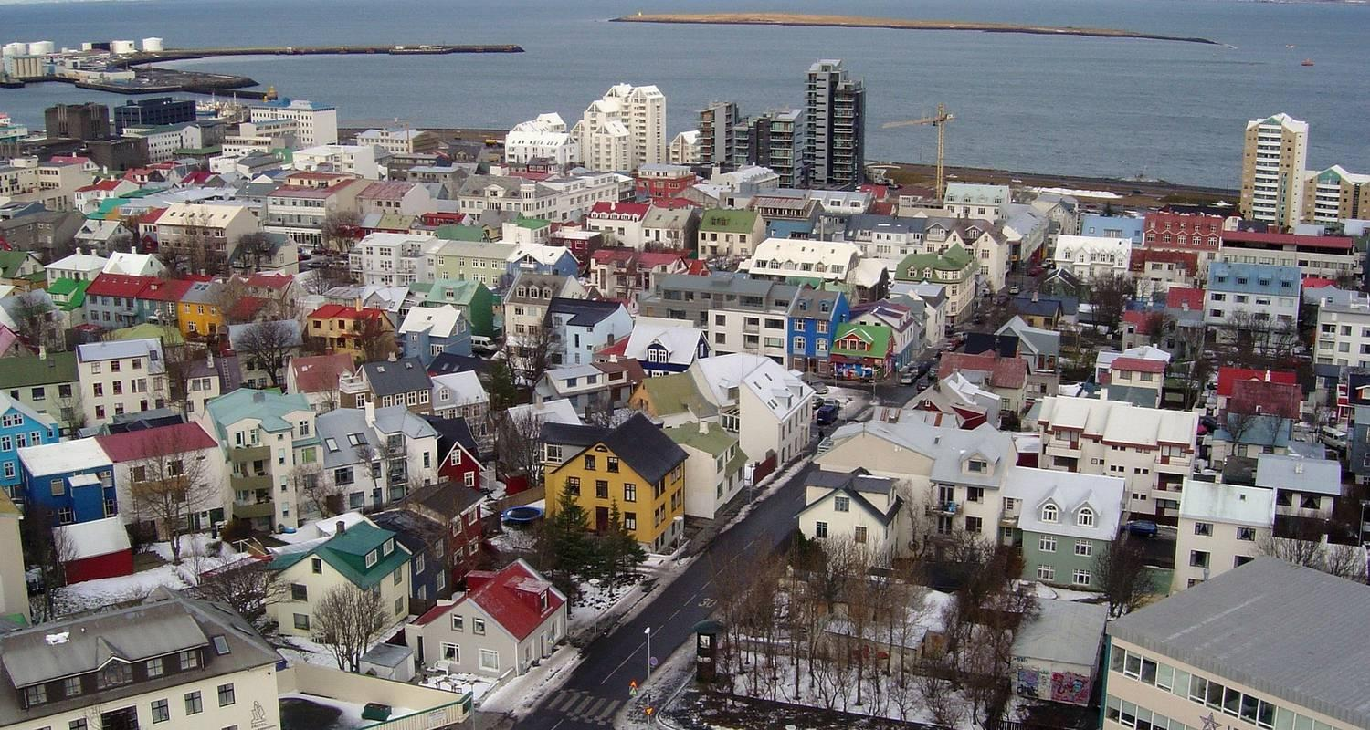

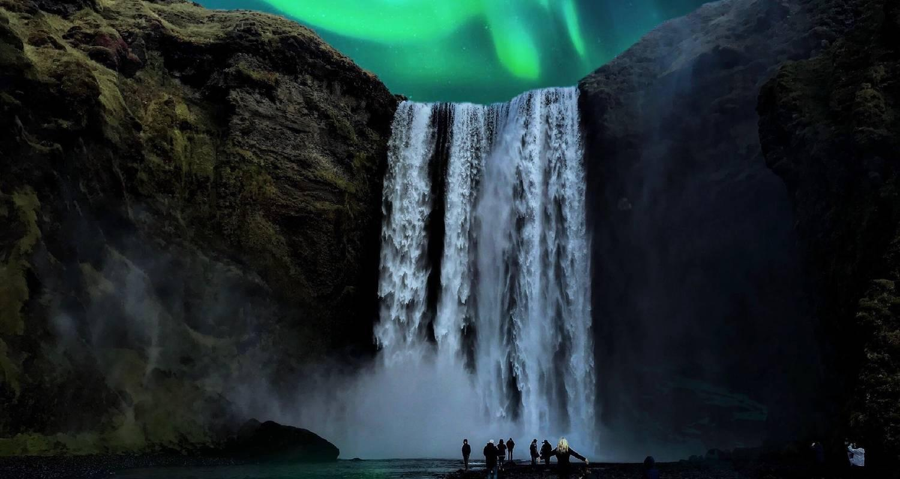

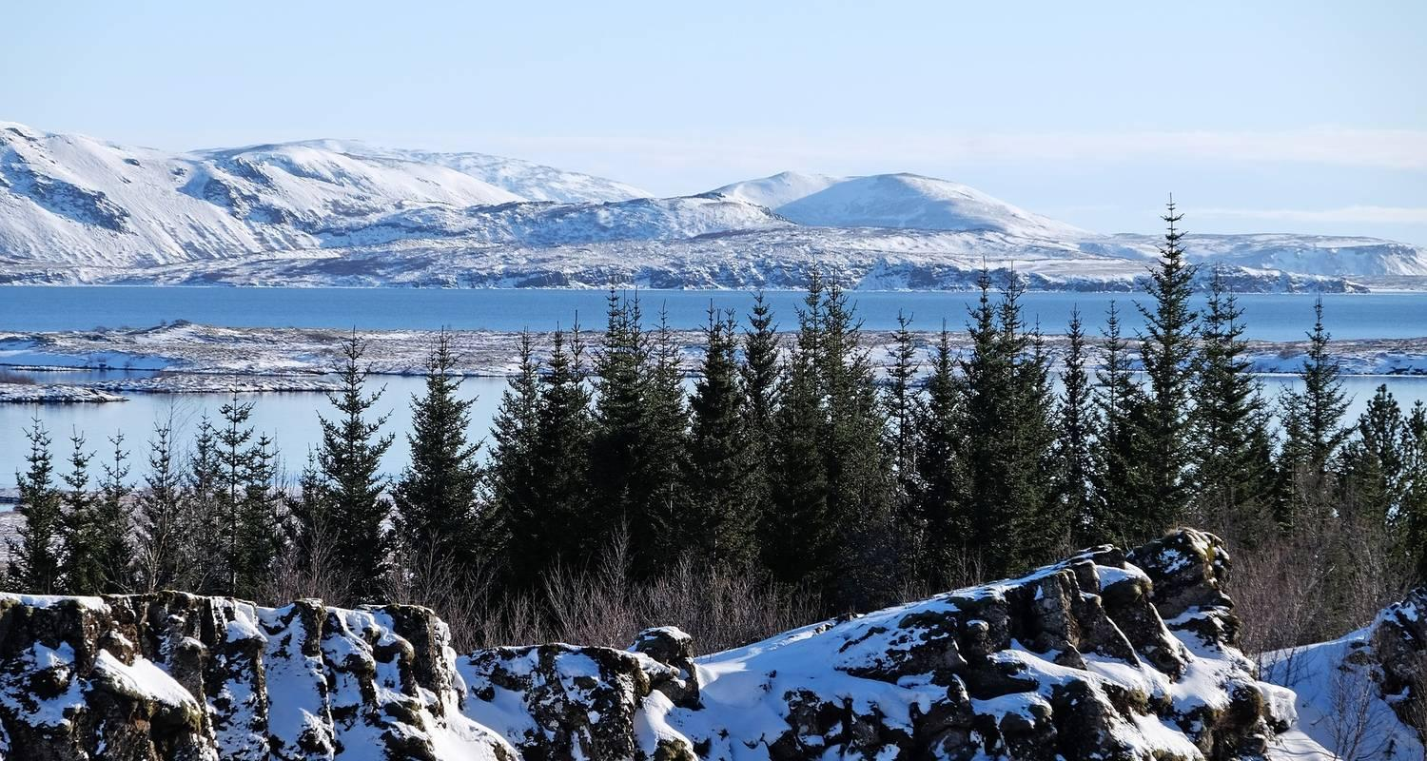

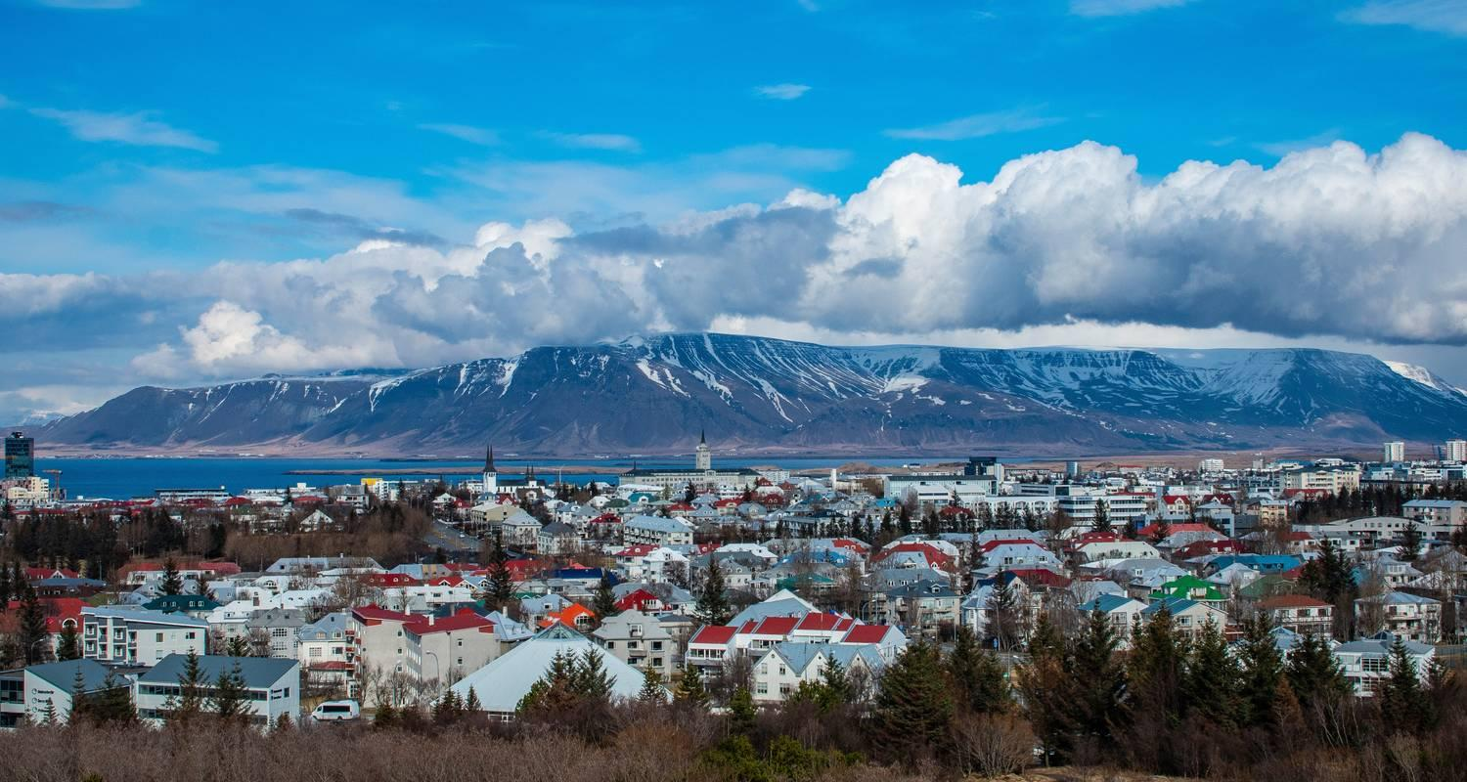

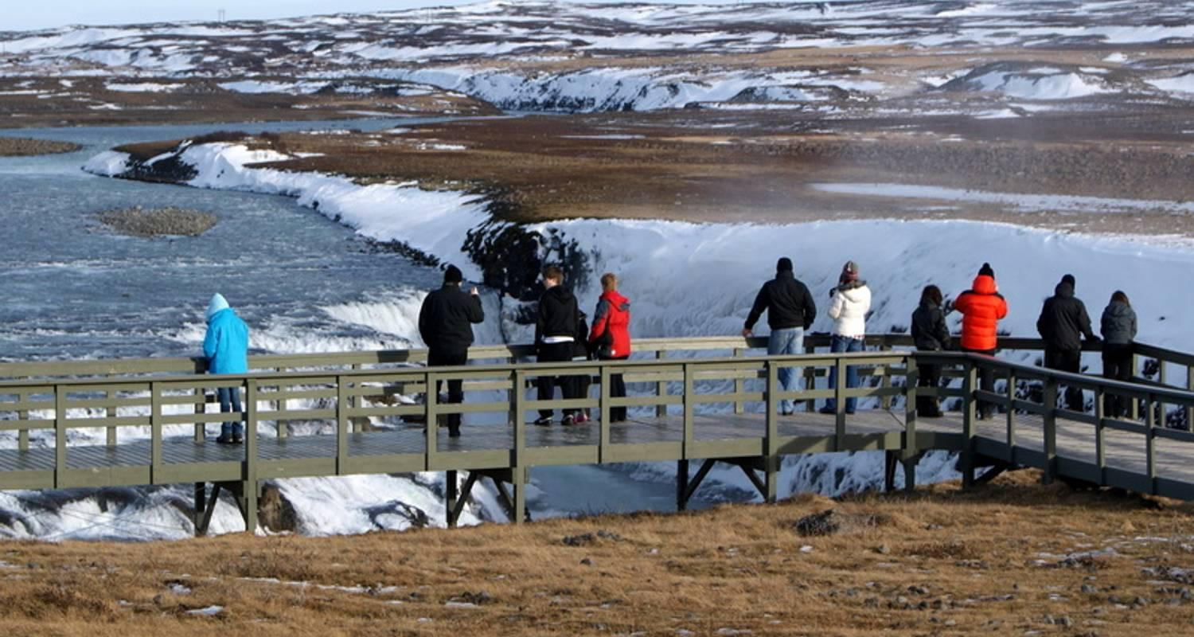

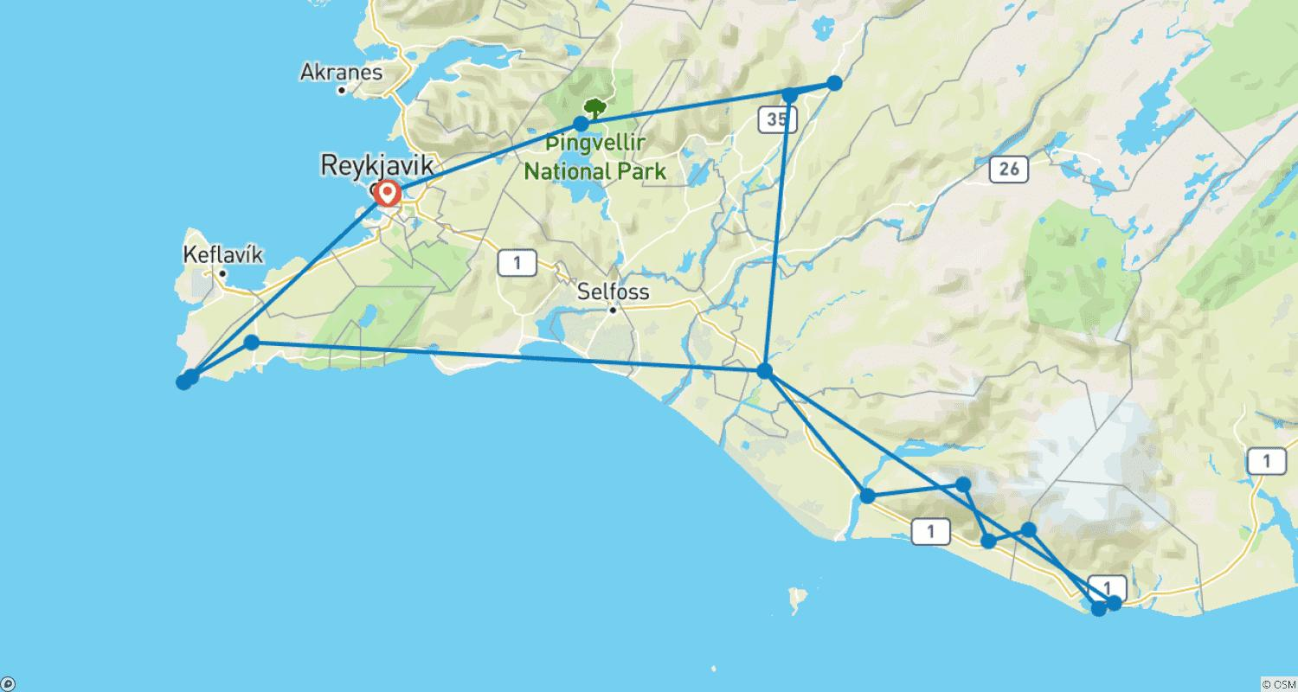

Tour ID: 98113  
Tour Name: 5 Days New Year's Northern Lights Adventure

Tour destinations: ['Reykjavik', 'Reykjanesviti', 'Gunnuhver', 'Blue Lagoon', 'Hella', 'Seljaland', 'Eyjafjallajokull', 'Skogafoss', 'Solheimajokull', 'Reynisfjara', 'Vik', 'Geysir', 'Gullfoss', 'Thingvellir National Park']

Tour destinations images:

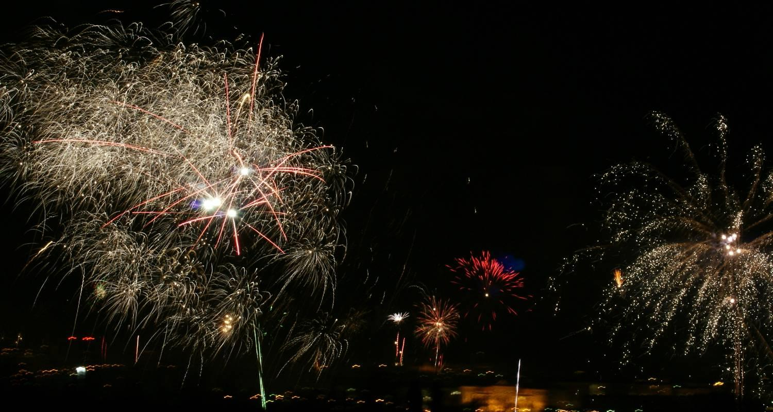

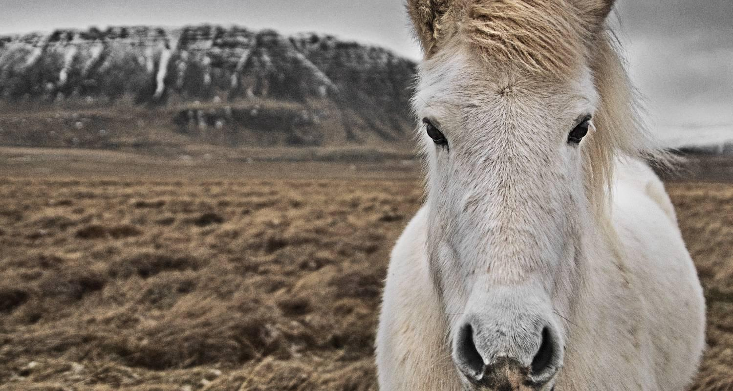

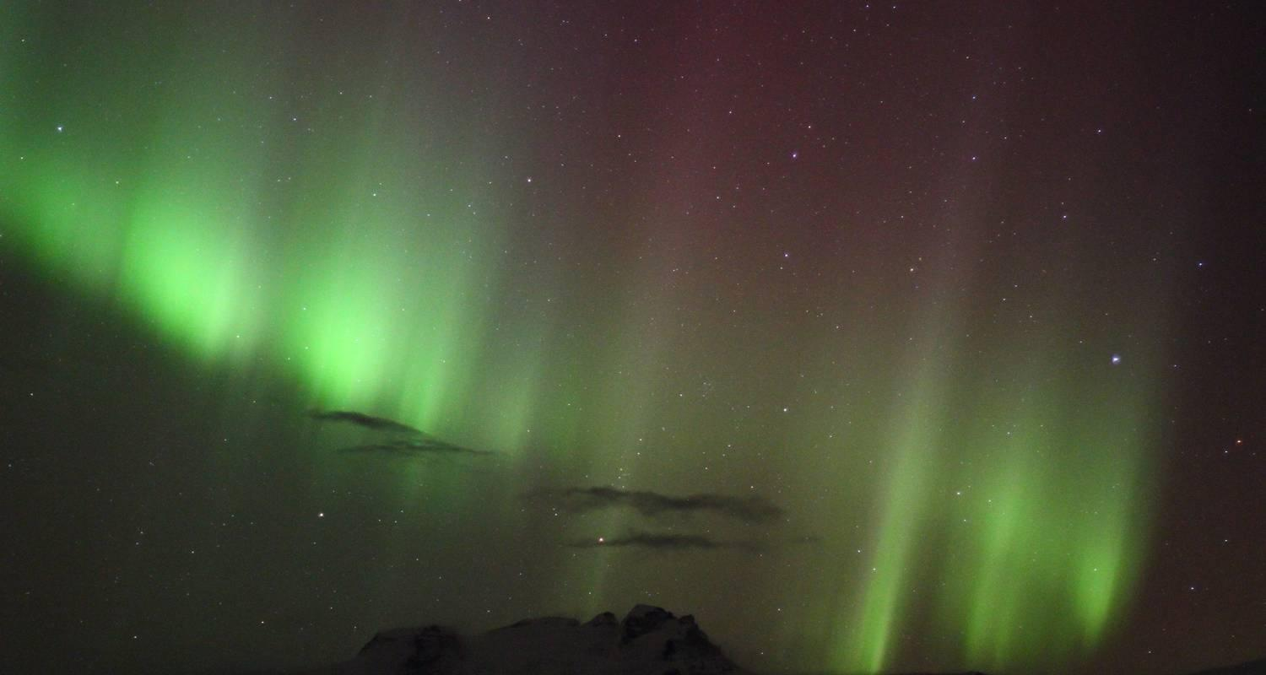

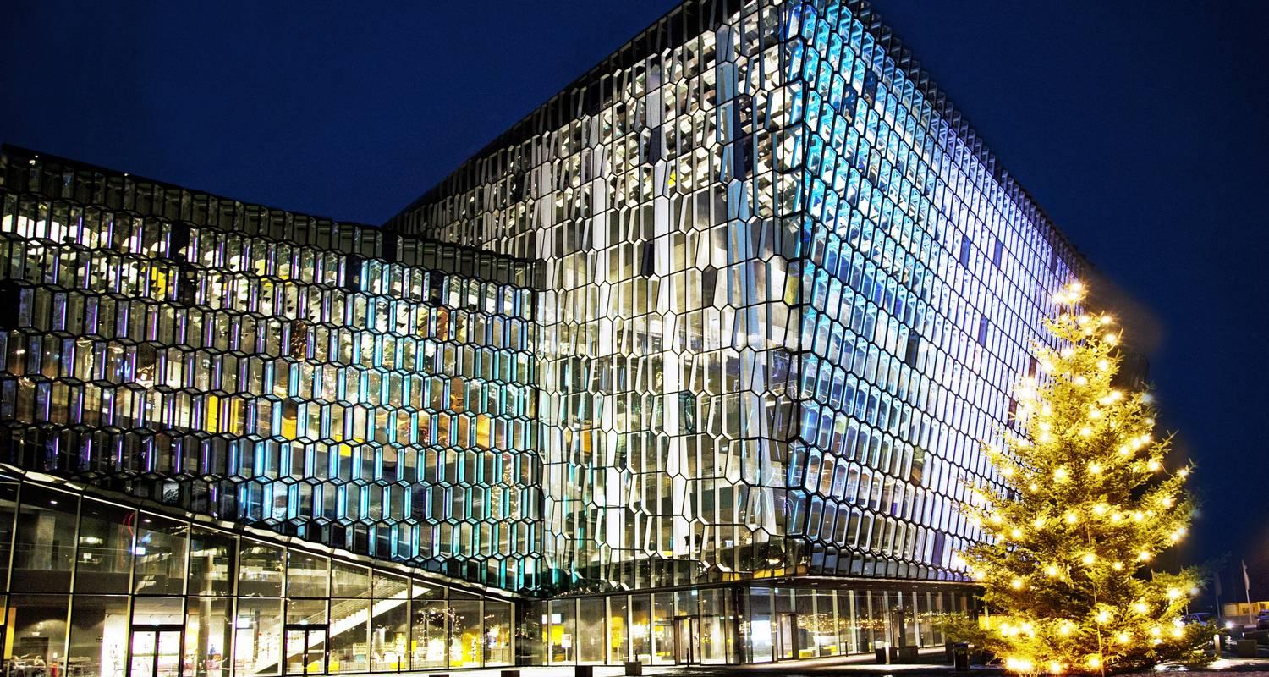

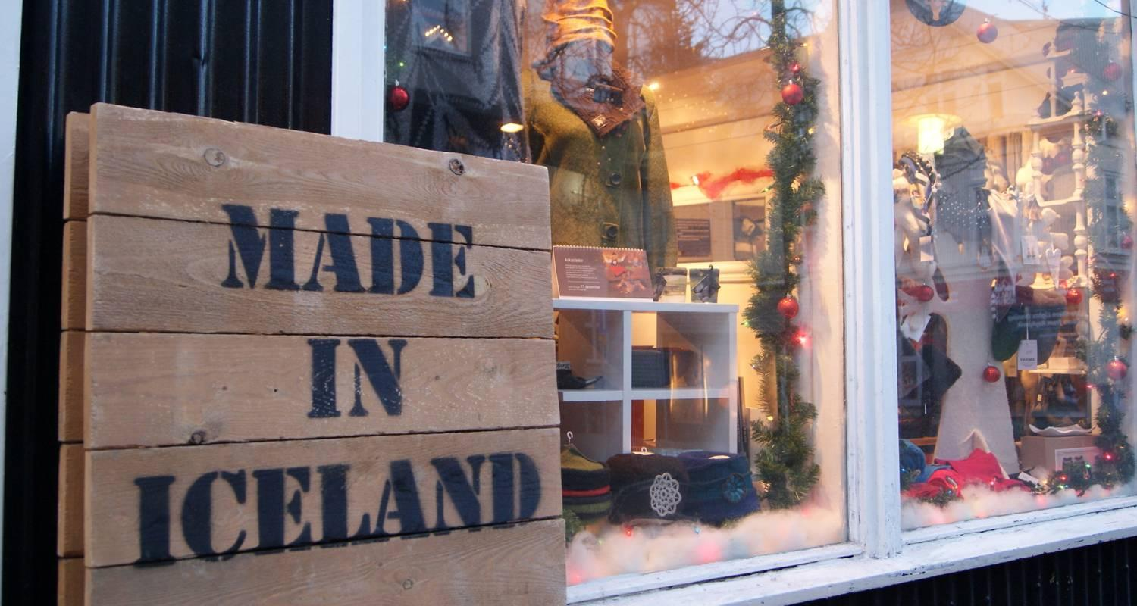

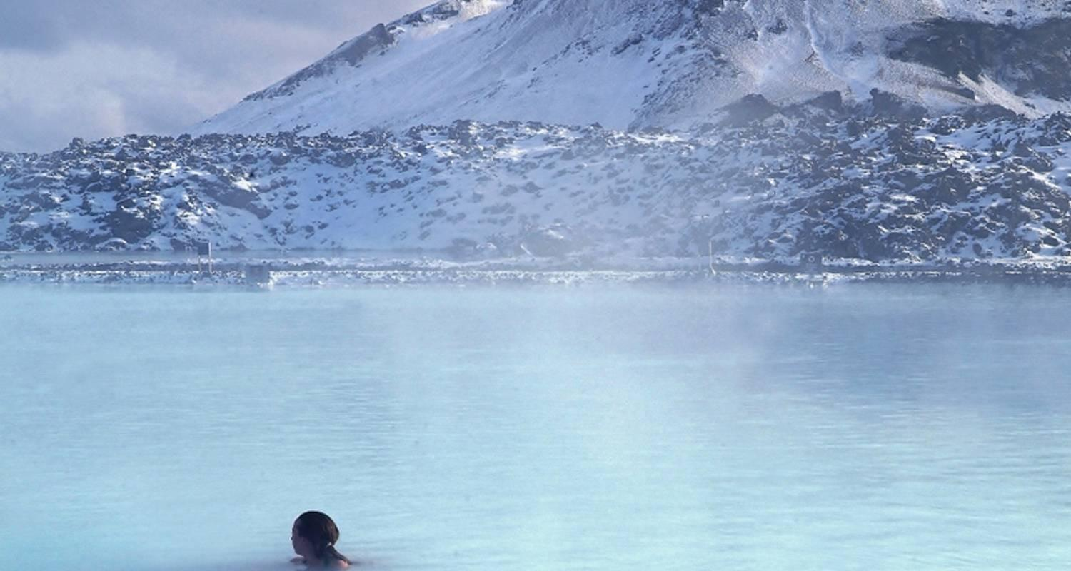

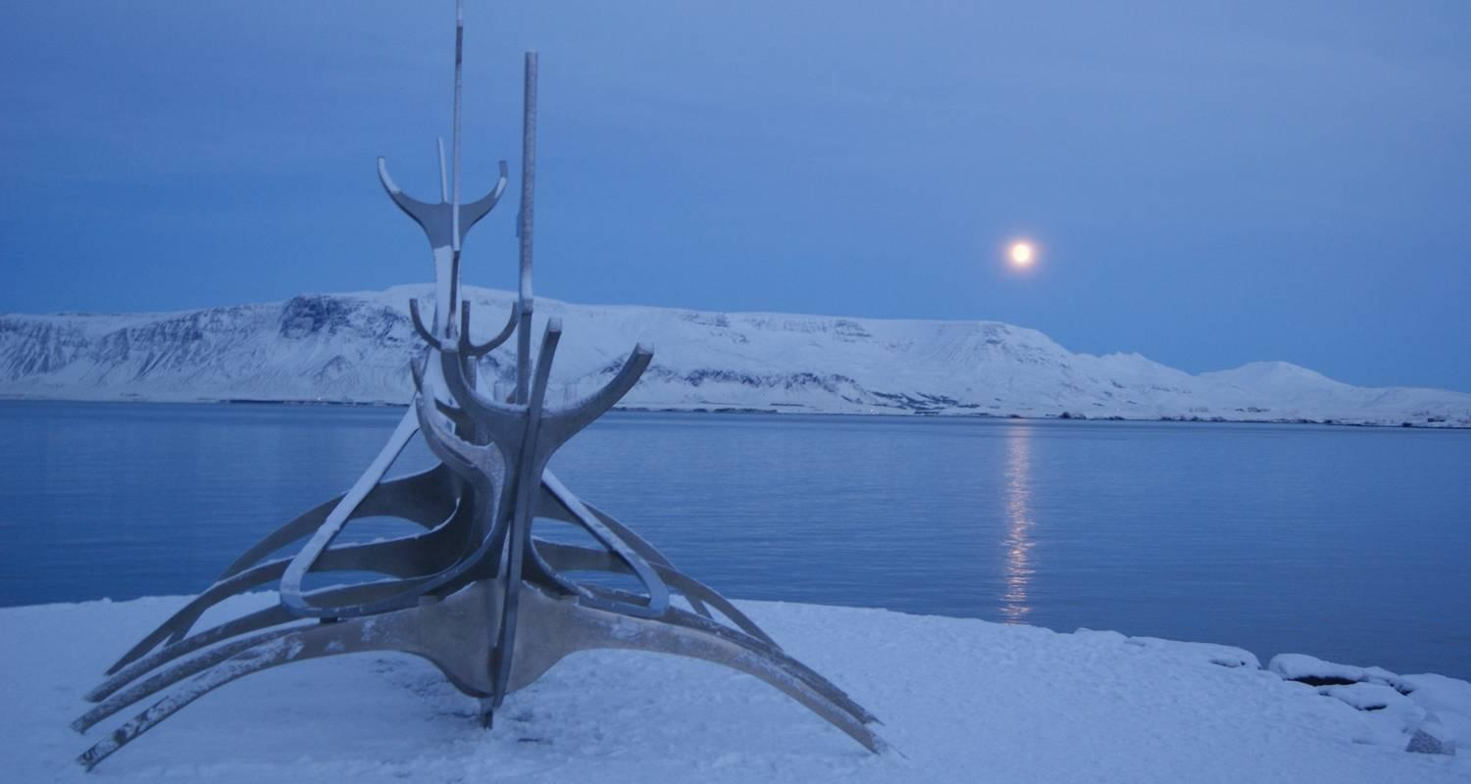

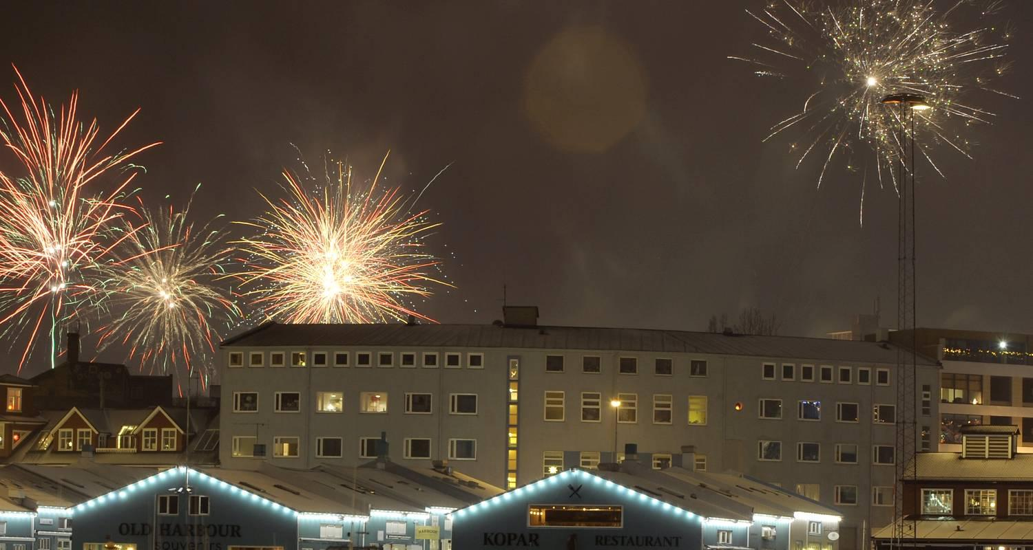

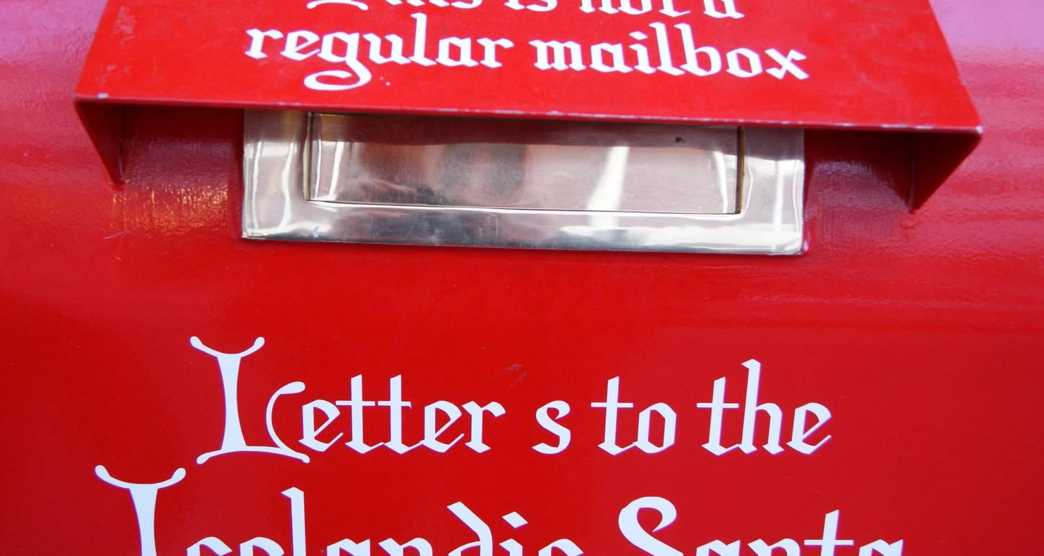

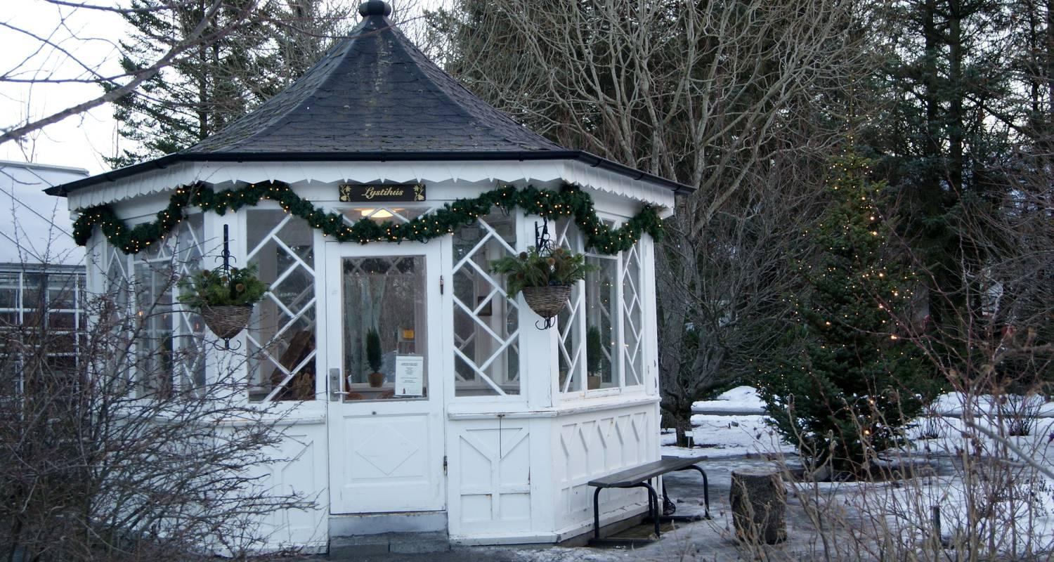



Tour ID: 98315  
Tour Name: Golden Circle & South Coast Adventure 3D/2N

Tour destinations: ['Reykjavik', 'Vik', 'Skaftafell']

Tour destinations images:

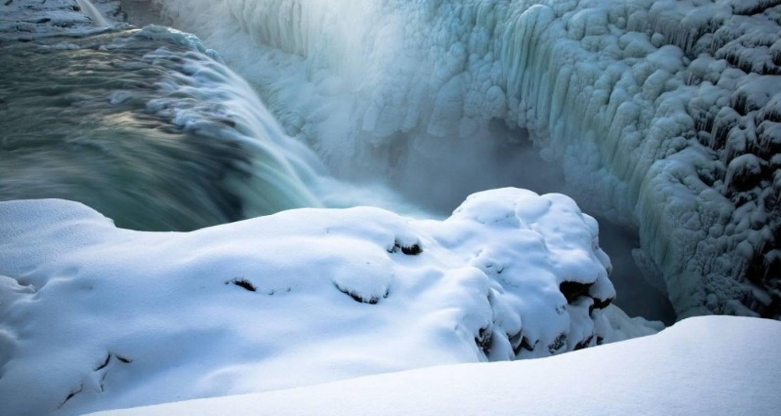

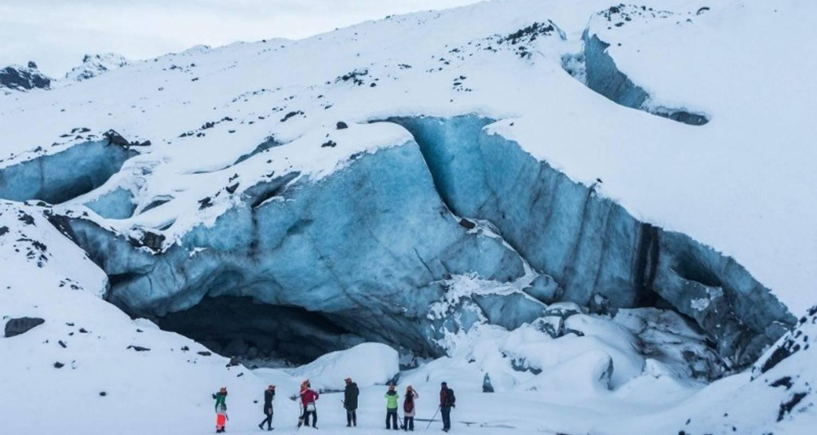

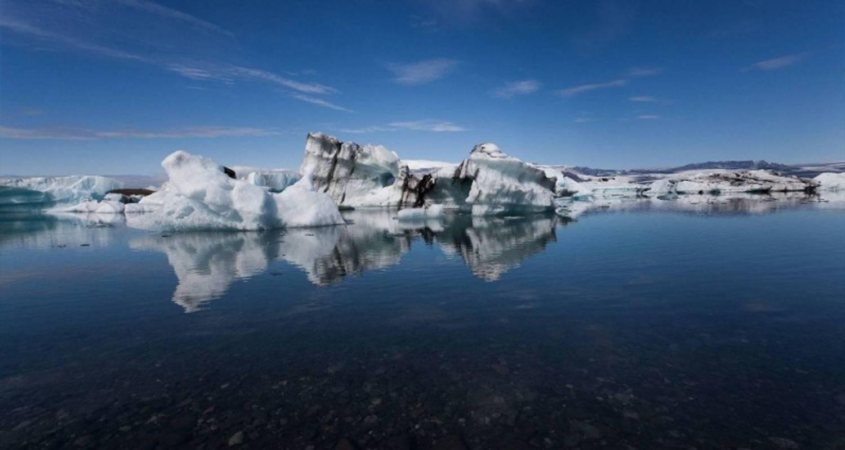

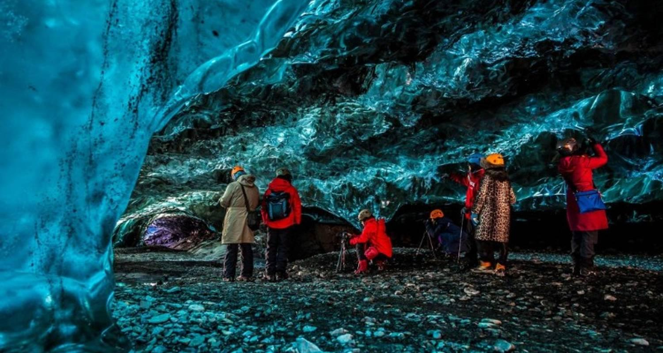

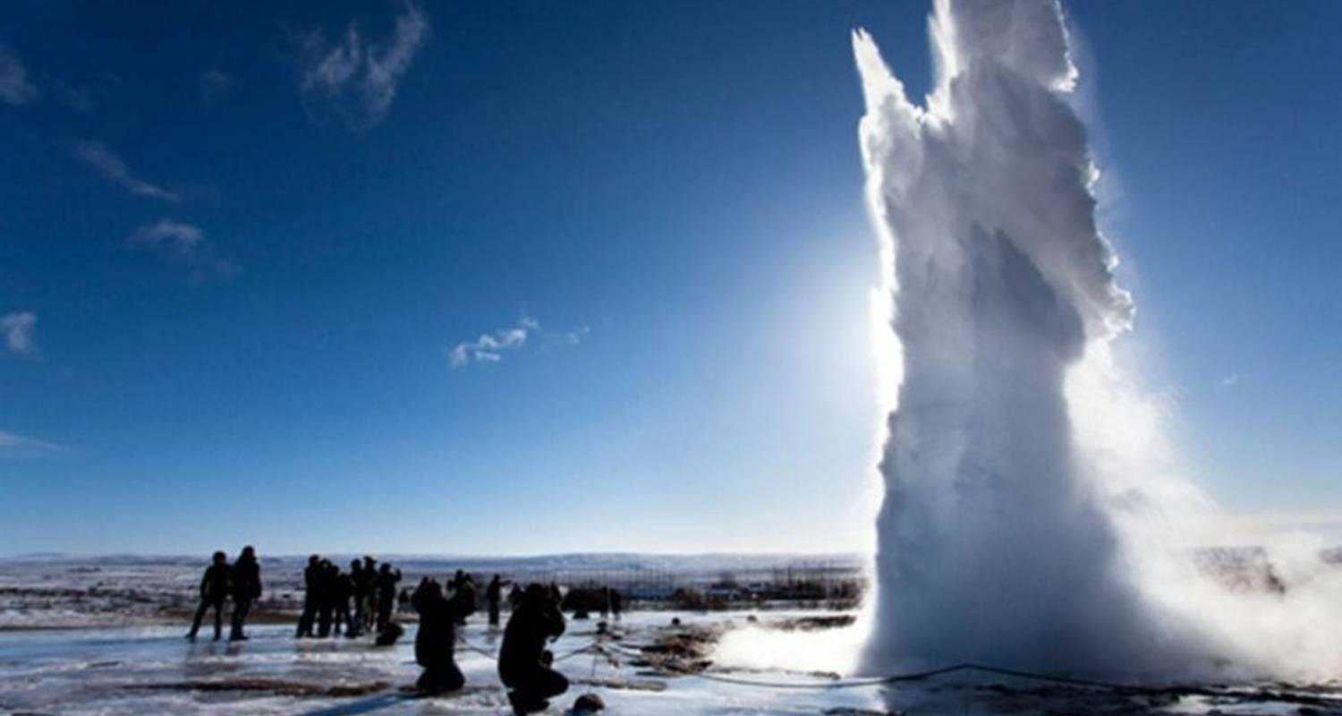

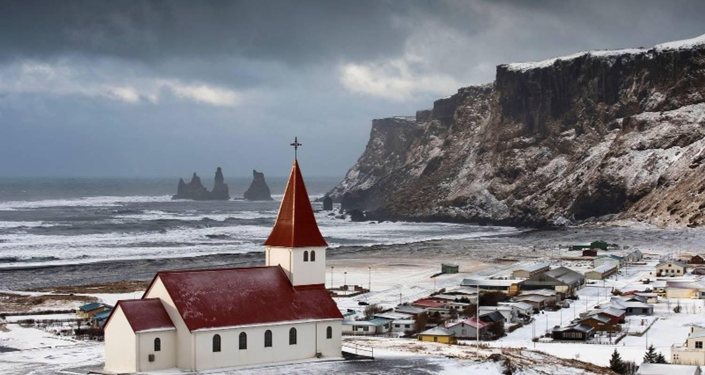

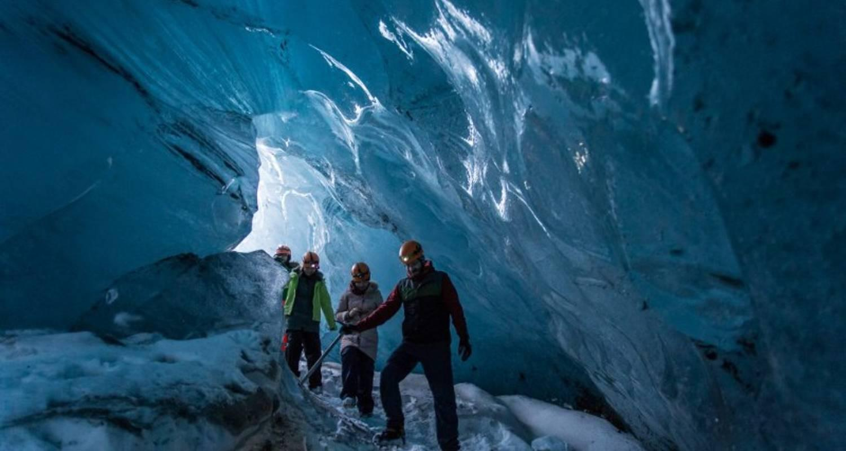

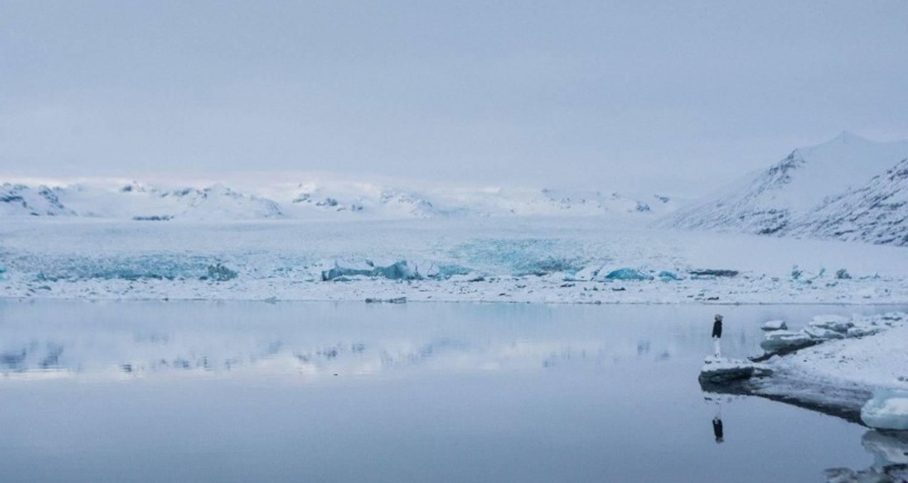

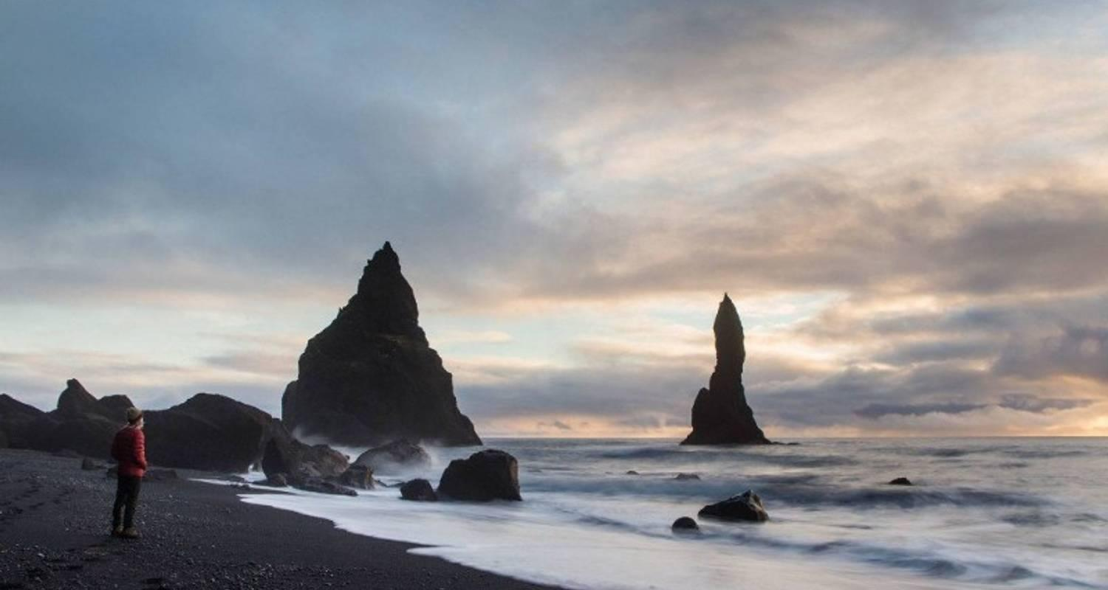

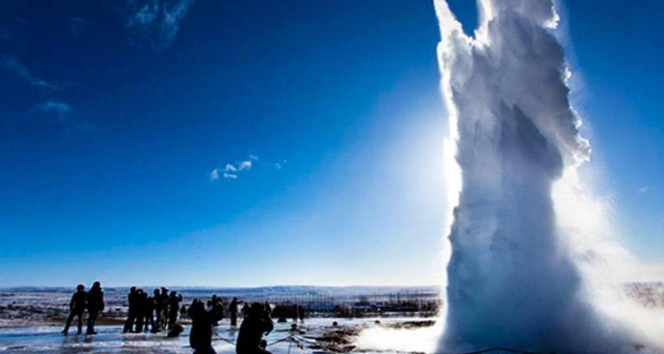

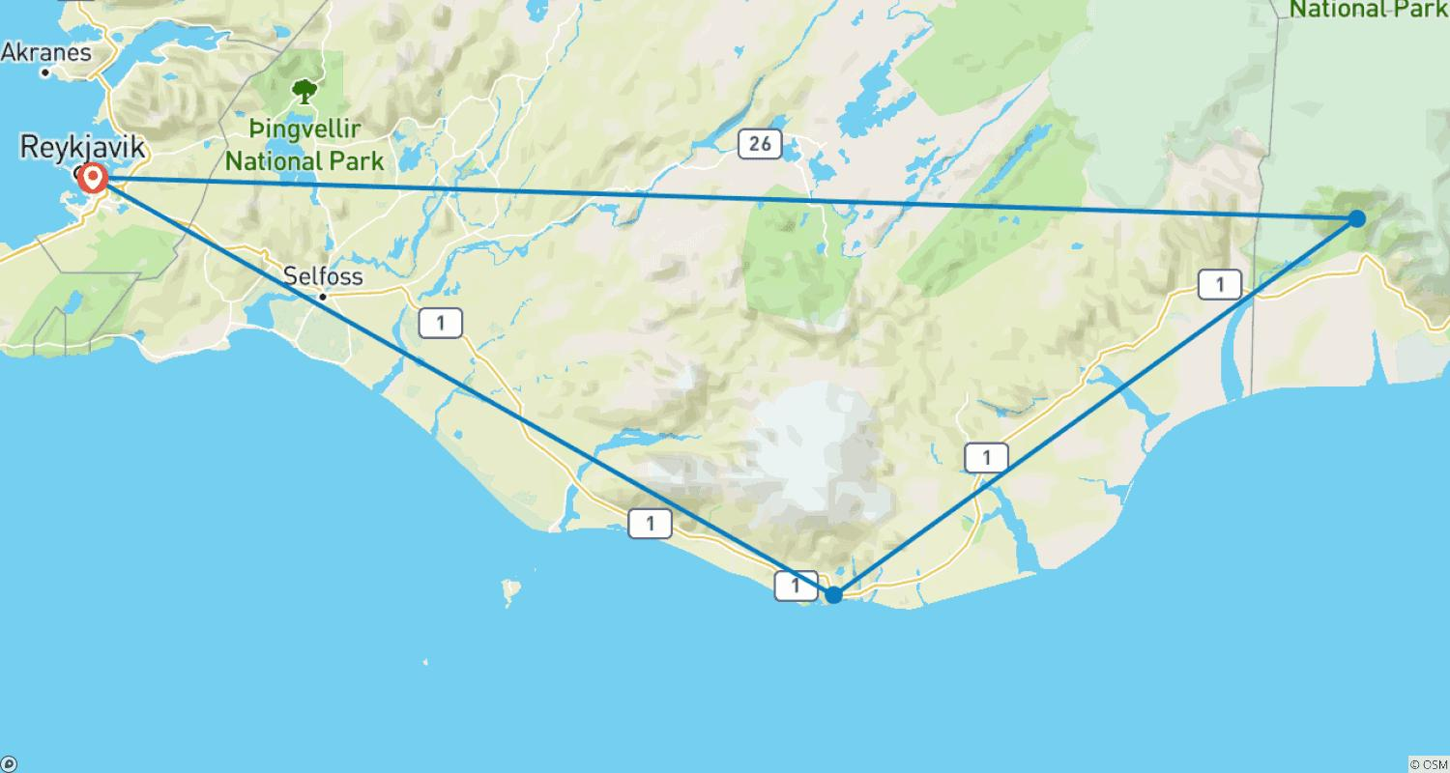

Tour ID: 98752  
Tour Name: Iceland Adventurer 6D/5N

Tour destinations: ['Reykjavik', 'Vik', 'Hofn', 'Egilsstadir', 'Akureyri', 'Bifrost']

Tour destinations images:

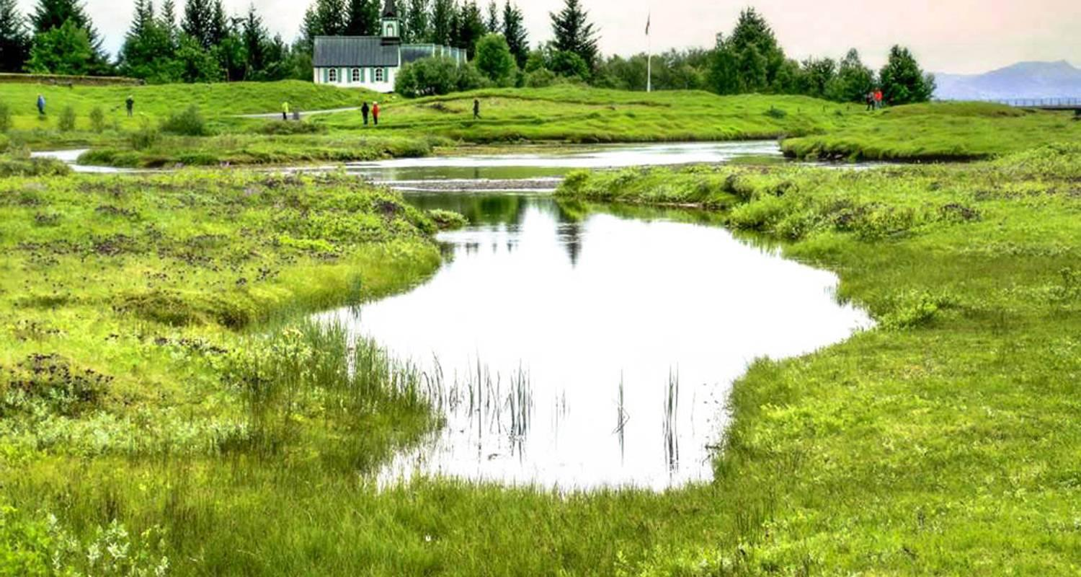

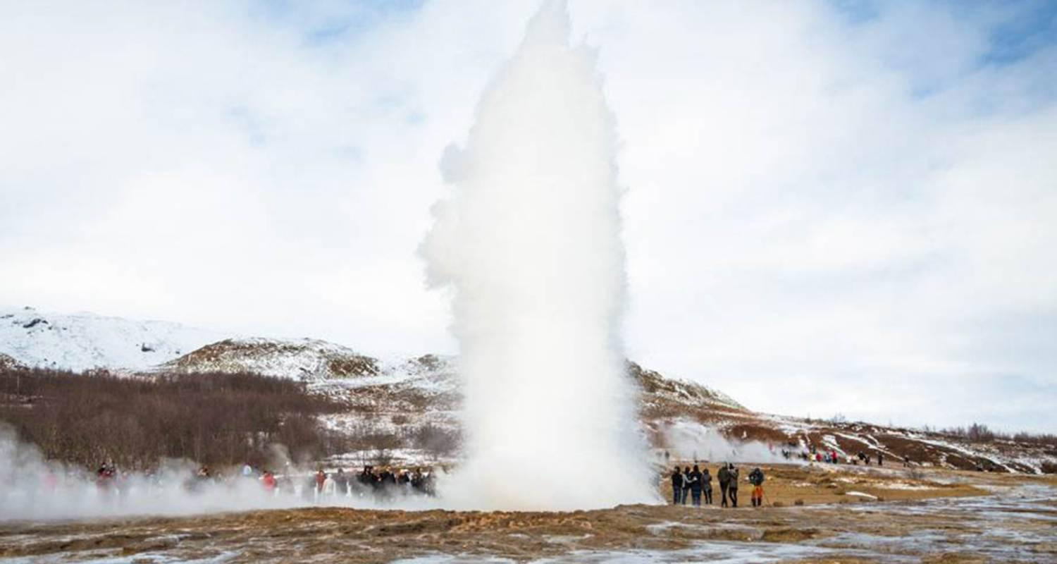

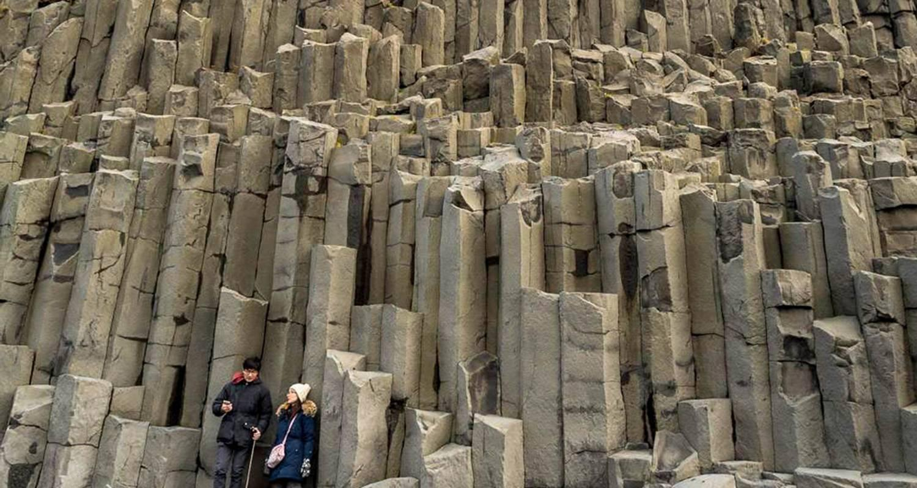

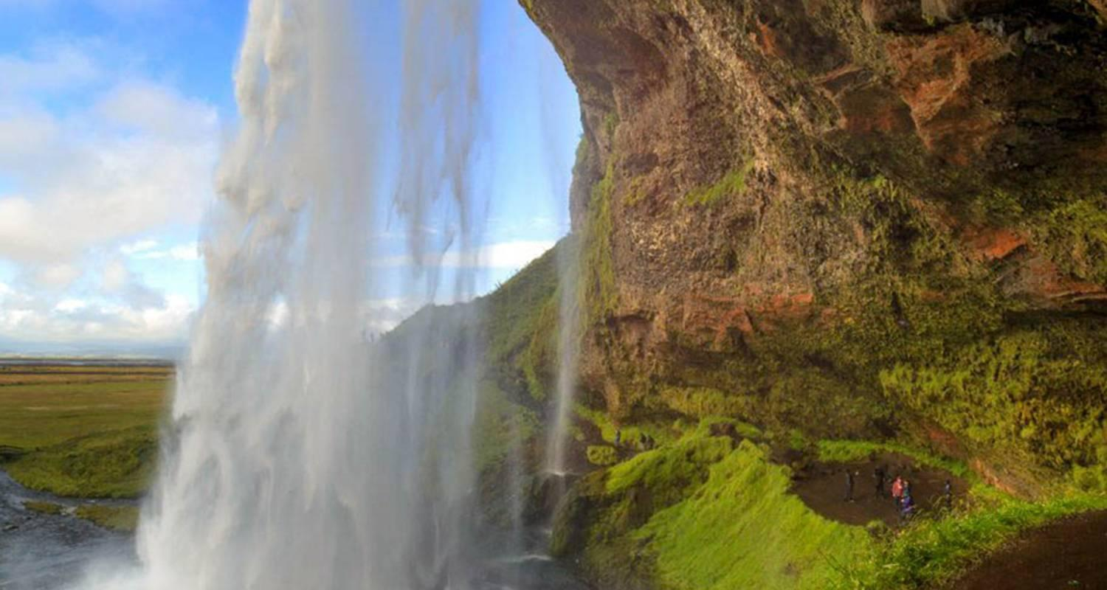

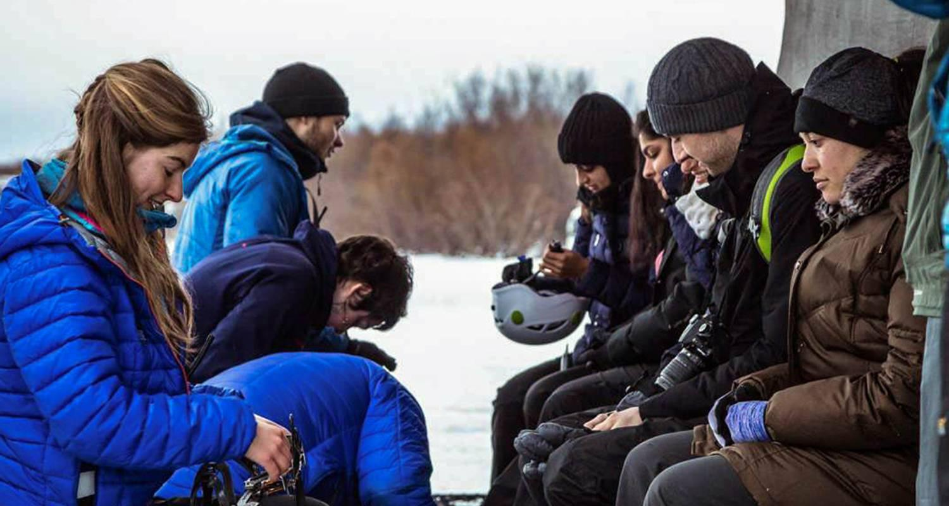

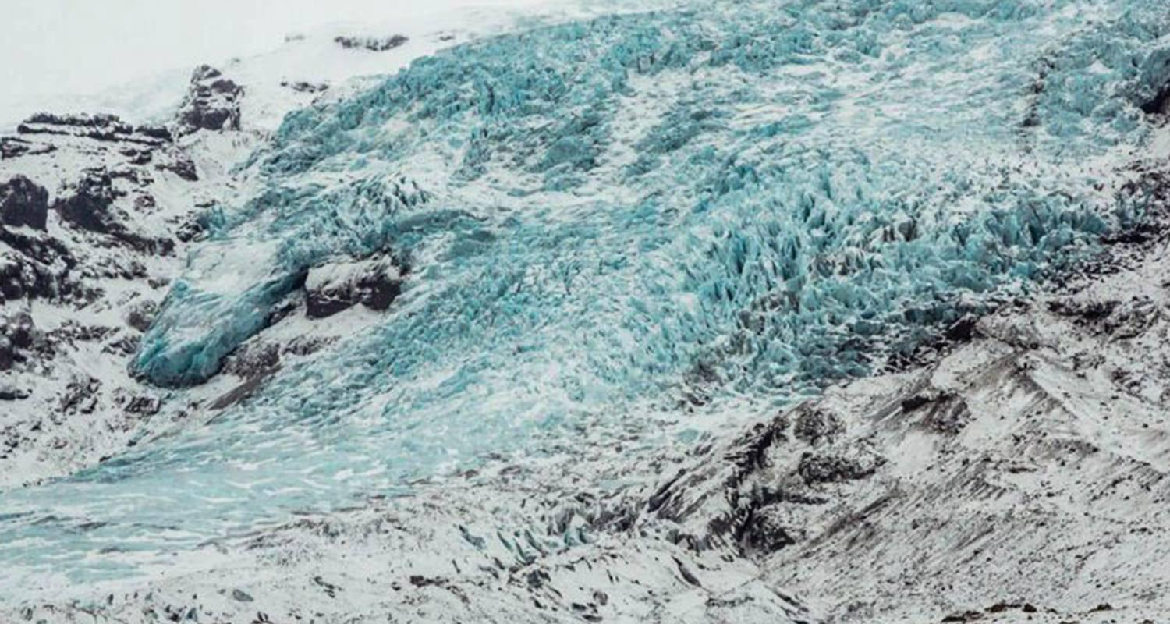

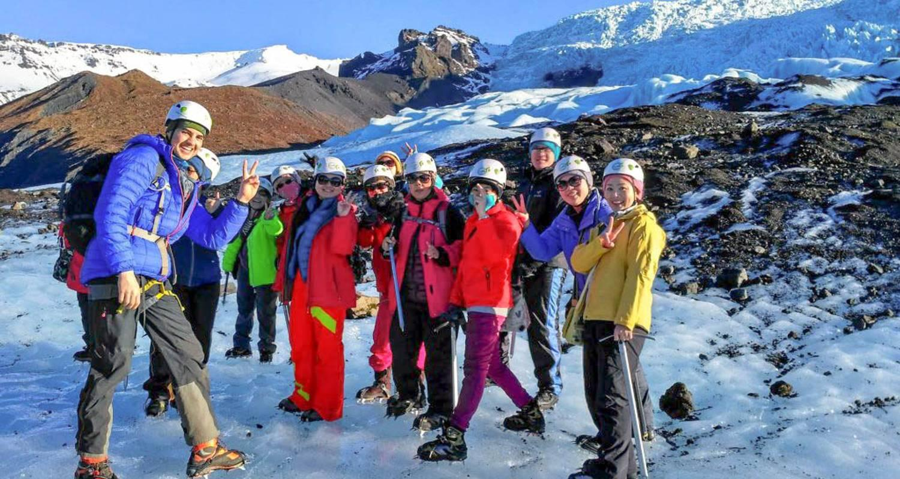

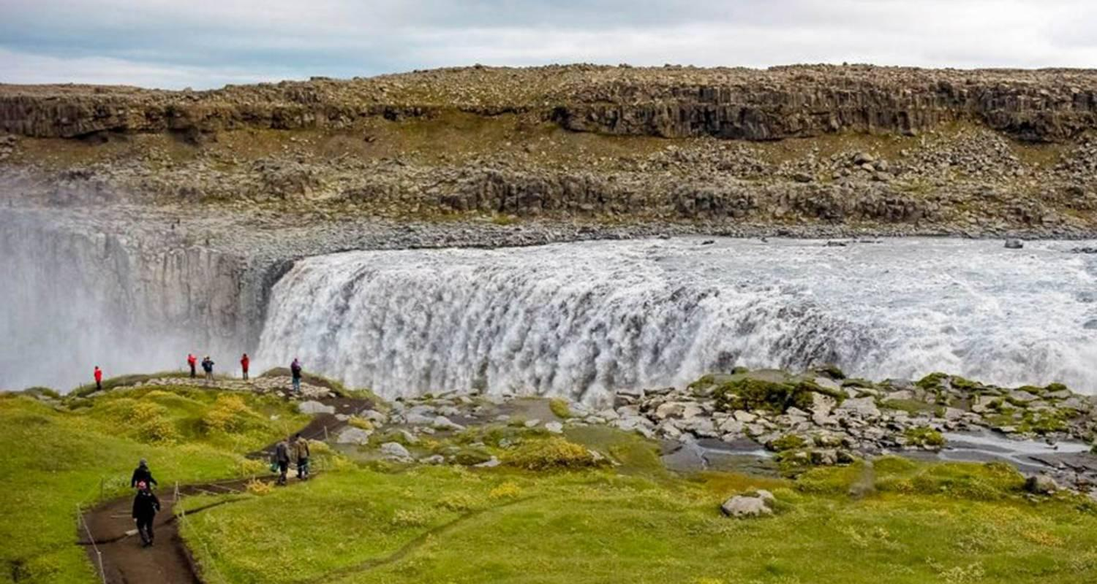

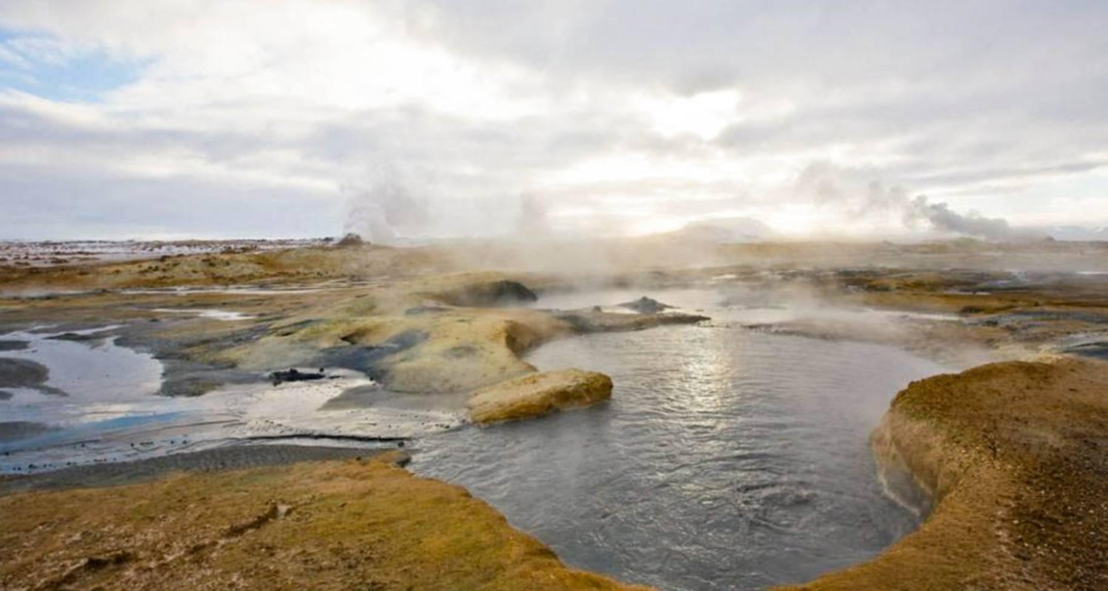

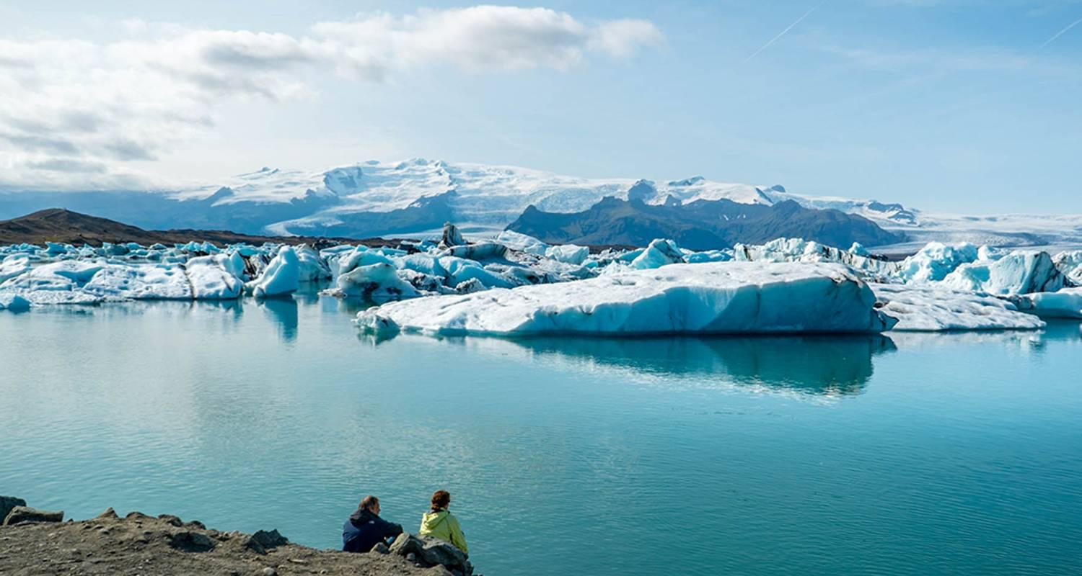

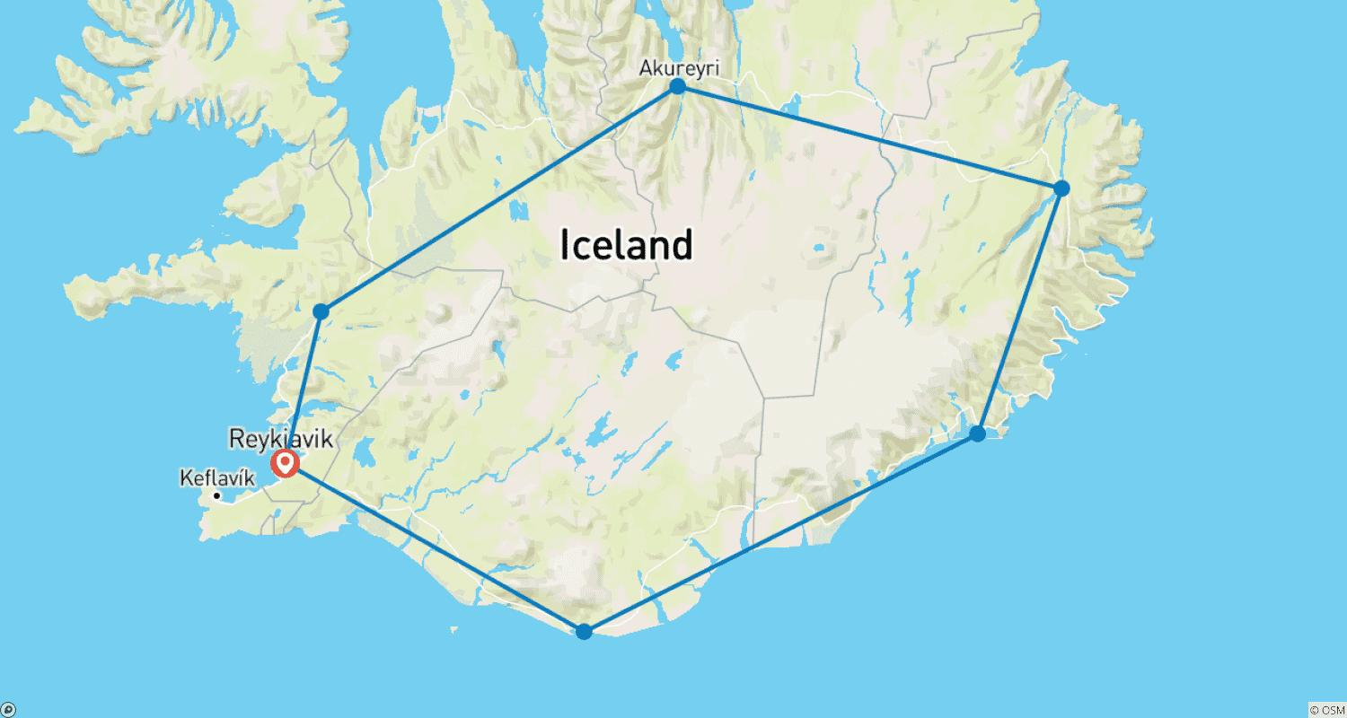

Tour ID: 100785  
Tour Name: 9 days Guided tour | Iceland Complete – Northern Lights Edition

Tour destinations: ['Reykjavik', 'Hveragerdi', 'Geysir', 'Gullfoss', 'Seljaland', 'Skogafoss', 'Vik', 'Kirkjubaejarklaustur', 'Skaftafell', 'Jokulsarlon', 'Hofn', 'Djupivogur', 'Faskrudsfjordur', 'Egilsstadir', 'Dettifoss', 'Mount Namaskard', 'Skutustadagigar', 'Myvatn', 'Godafoss', 'Akureyri', 'Siglufjordur', 'Saudarkrokur', 'Borgarnes', 'Reykholt', 'Thingvellir National Park']

Tour destinations images:

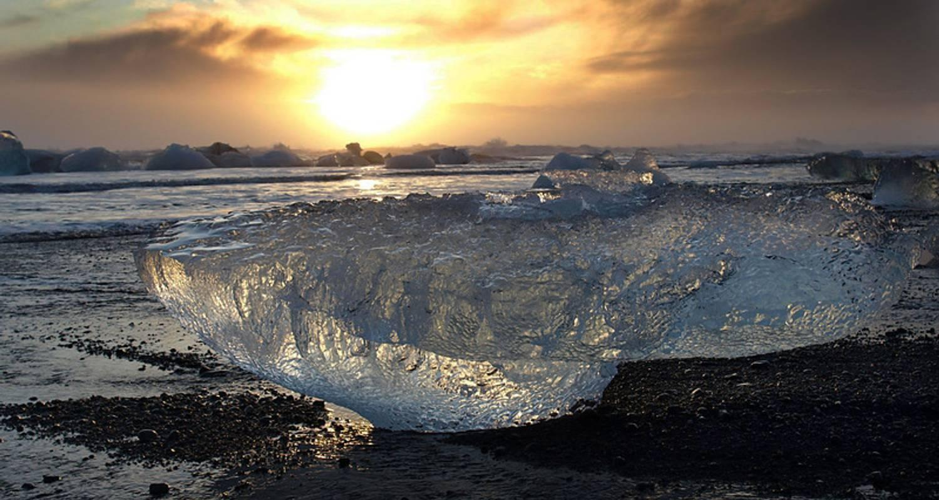

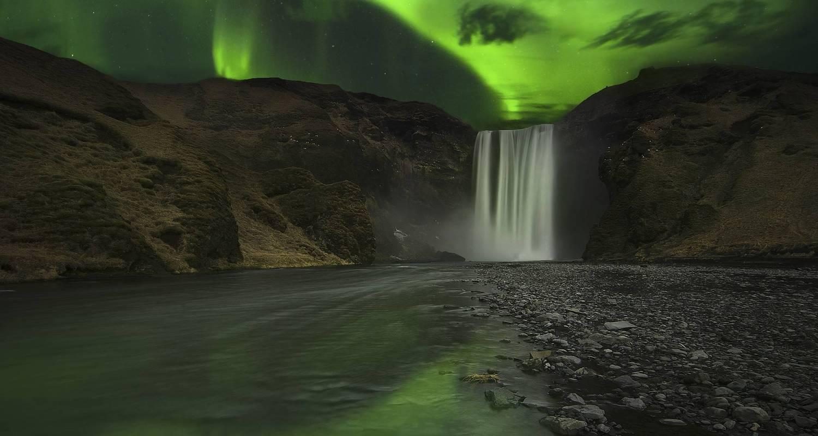

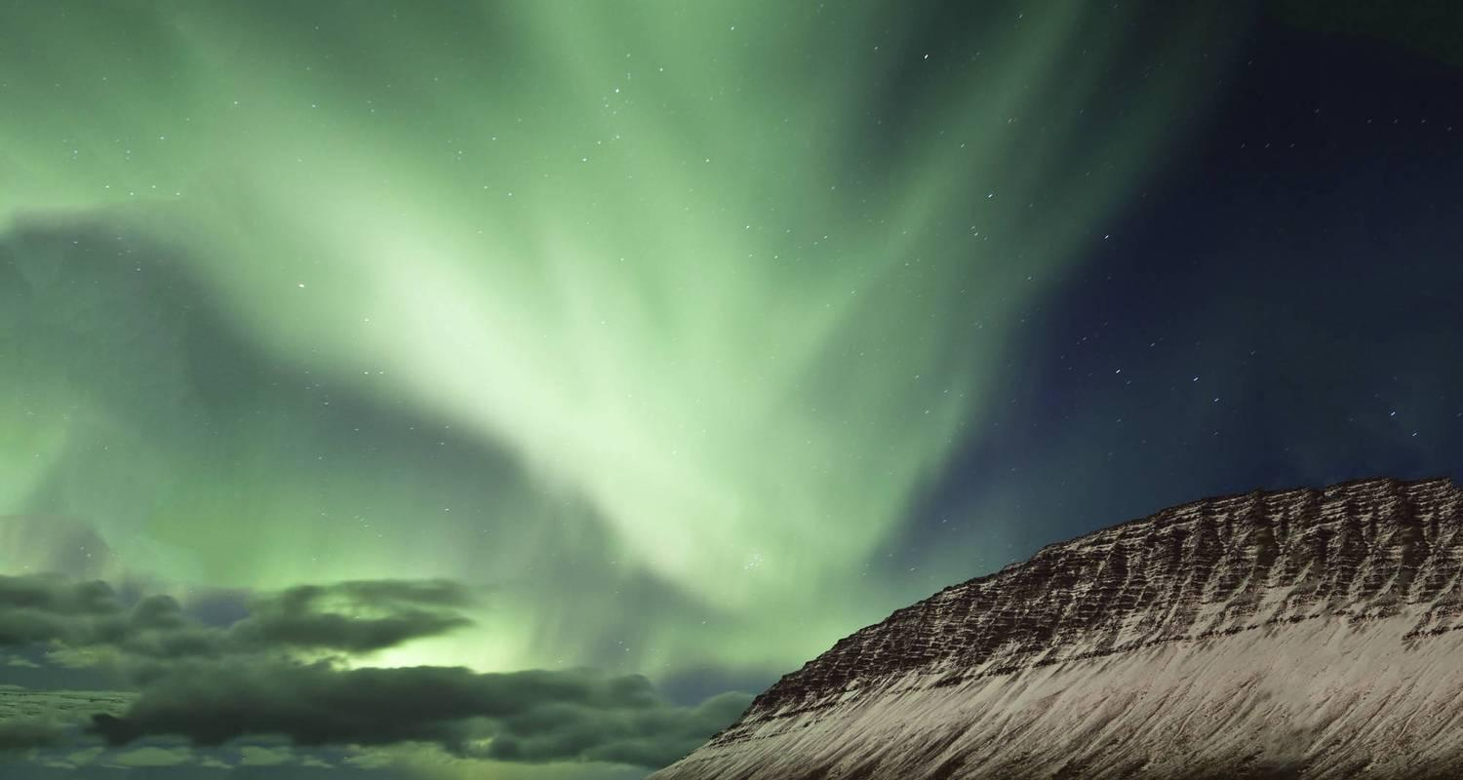

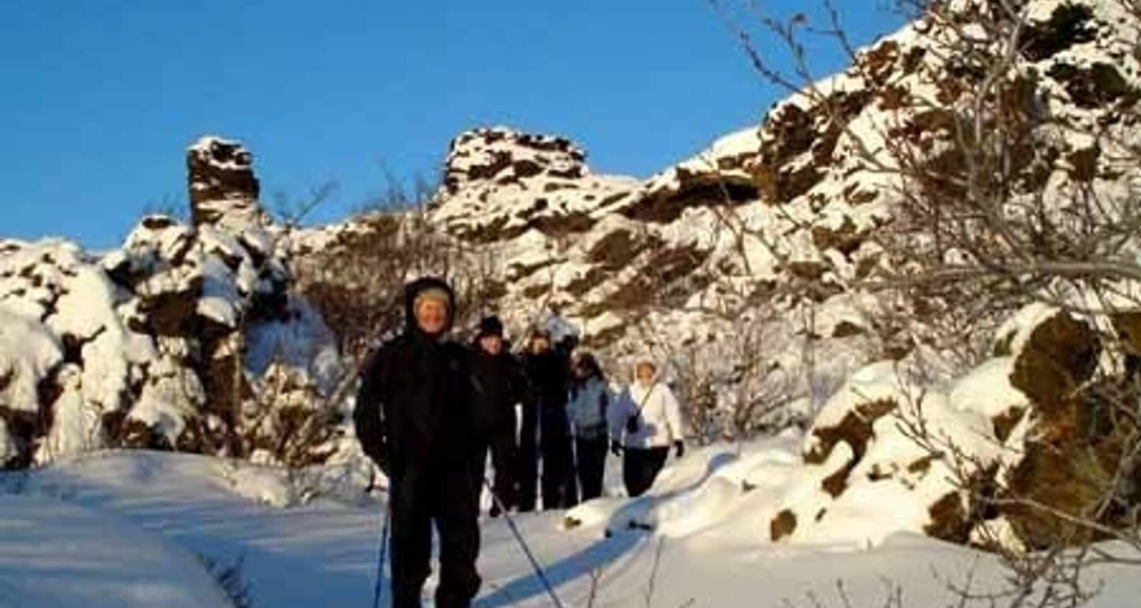

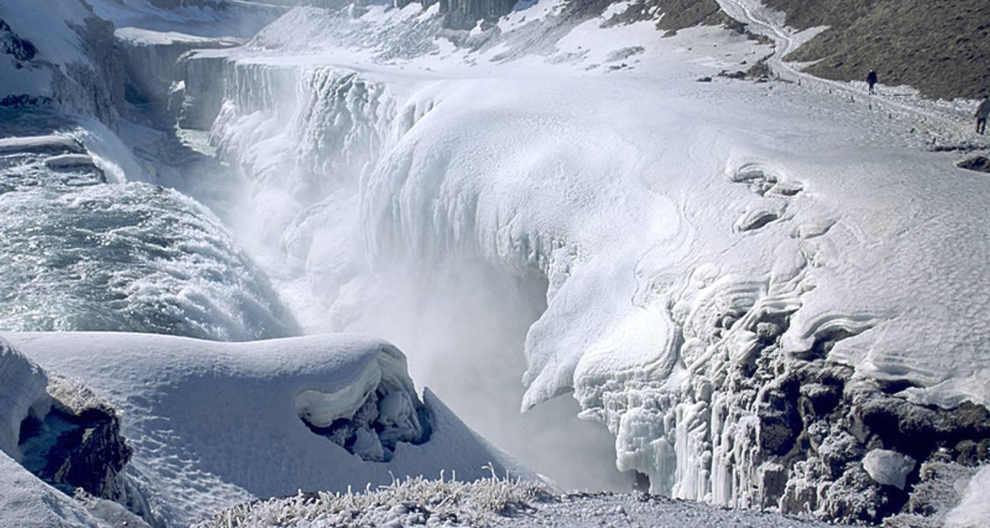

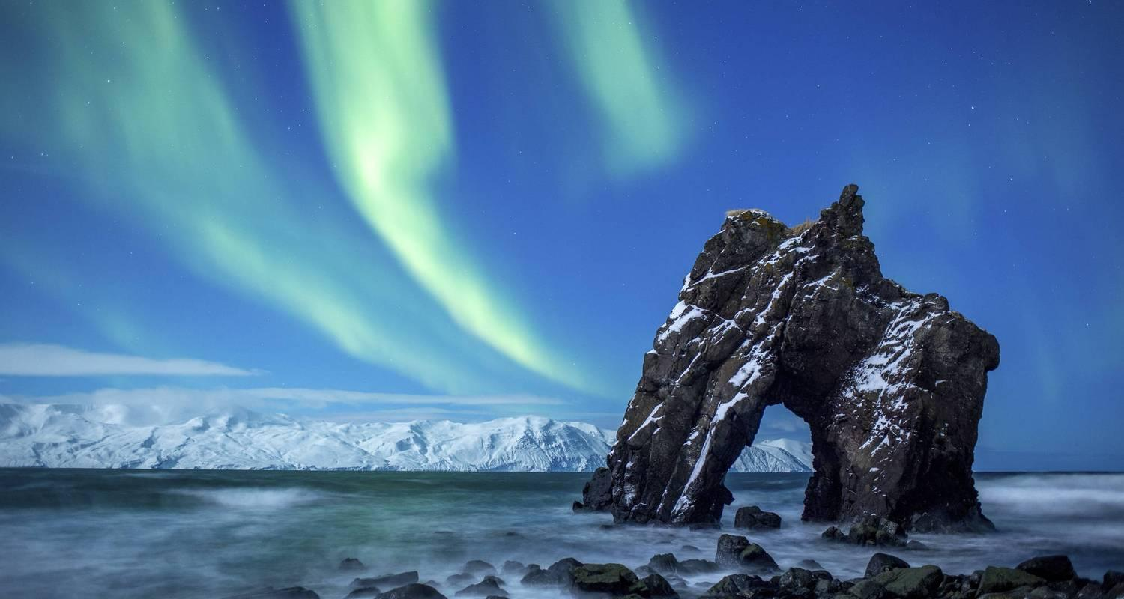

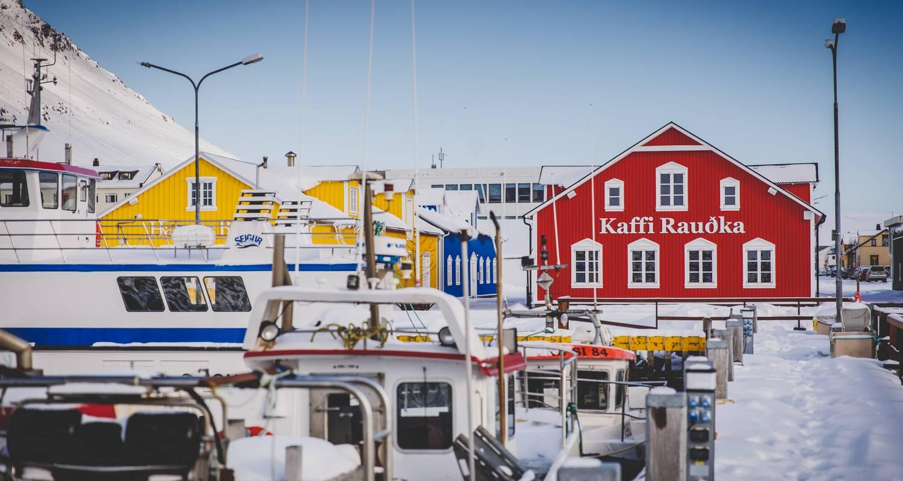

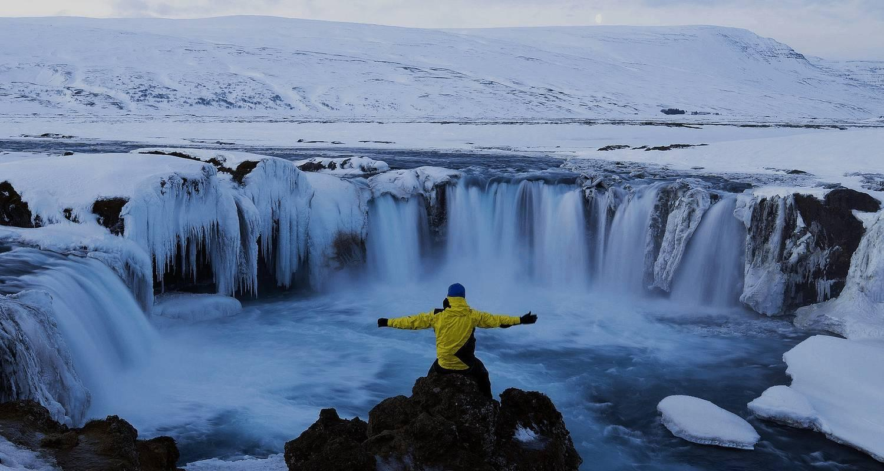

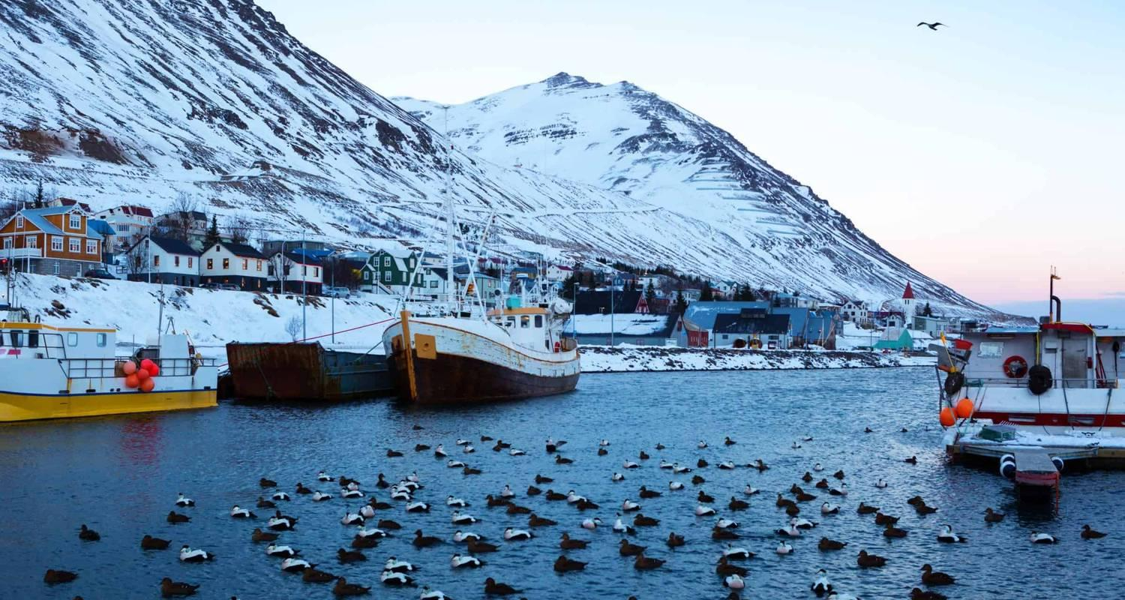

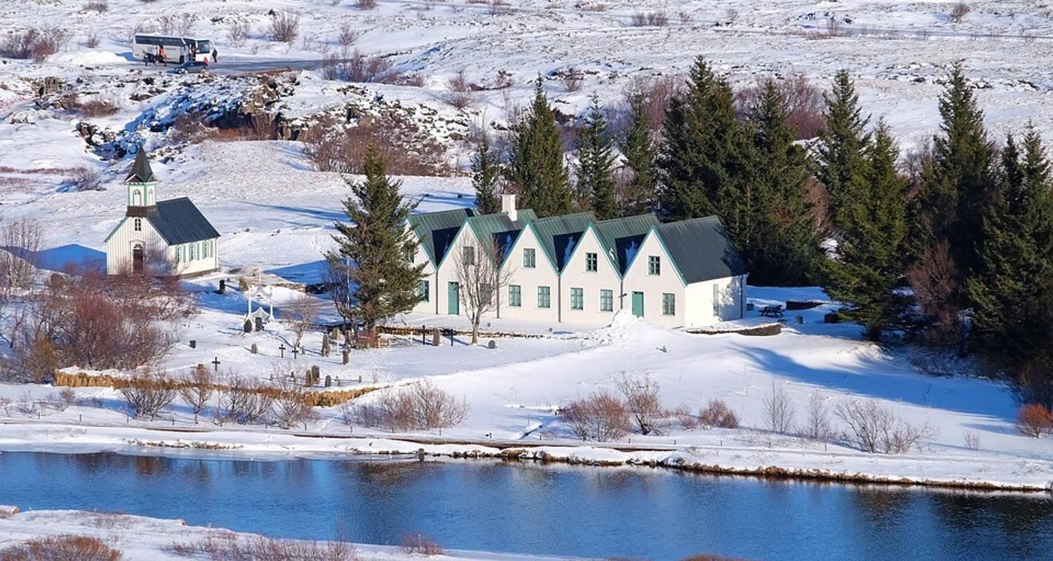

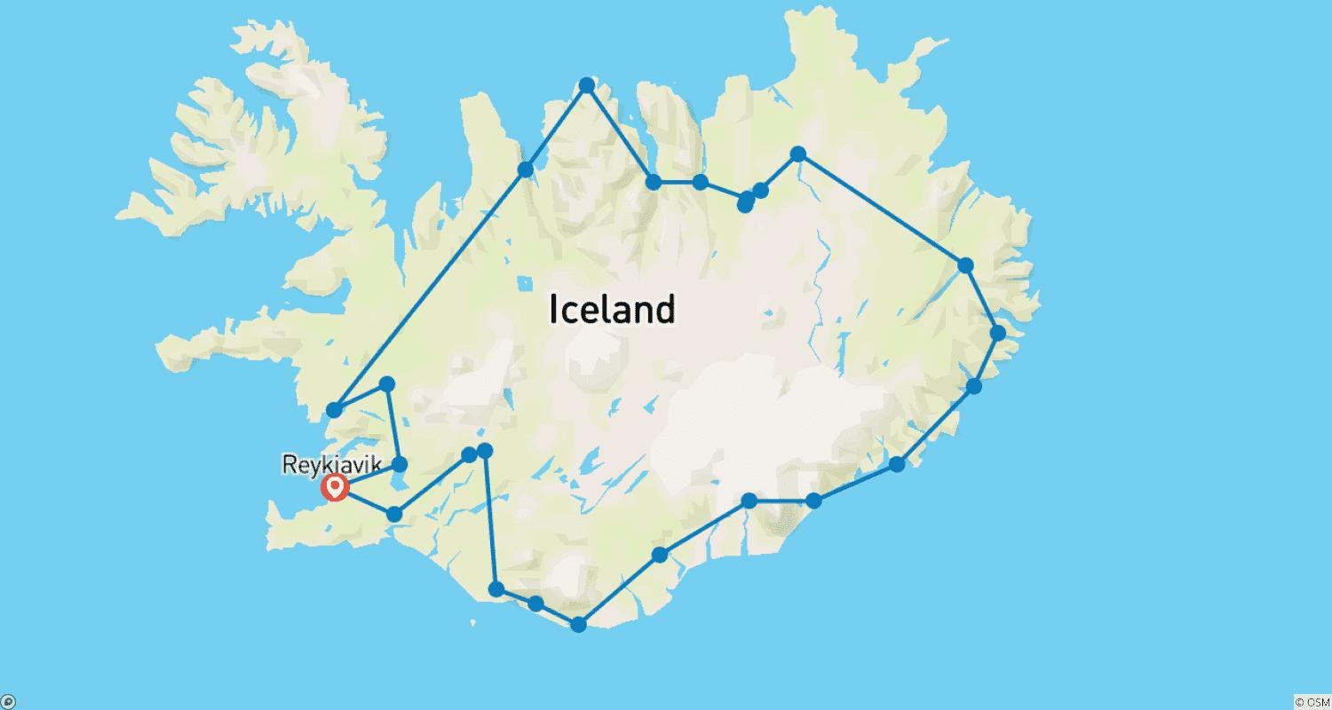

Tour ID: 100836  
Tour Name: 6 day Guided tour | Hidden Powers & Northern Lights Hunt - Small Group

Tour destinations: ['Reykjavik', 'Thingvellir National Park', 'Geysir', 'Gullfoss', 'Seljaland', 'Eyjafjallajokull', 'Skogafoss', 'Reynisfjara', 'Kirkjubaejarklaustur', 'Skaftafell', 'Jokulsarlon', 'Hveragerdi', 'Blue Lagoon']

Tour destinations images:

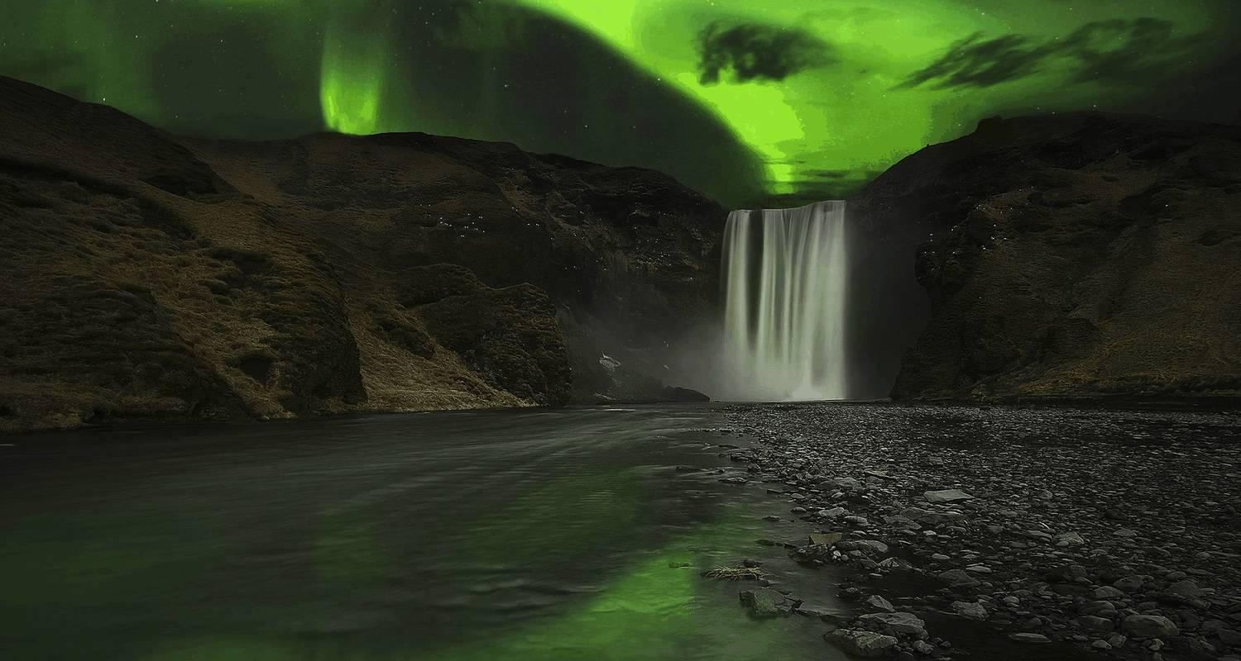

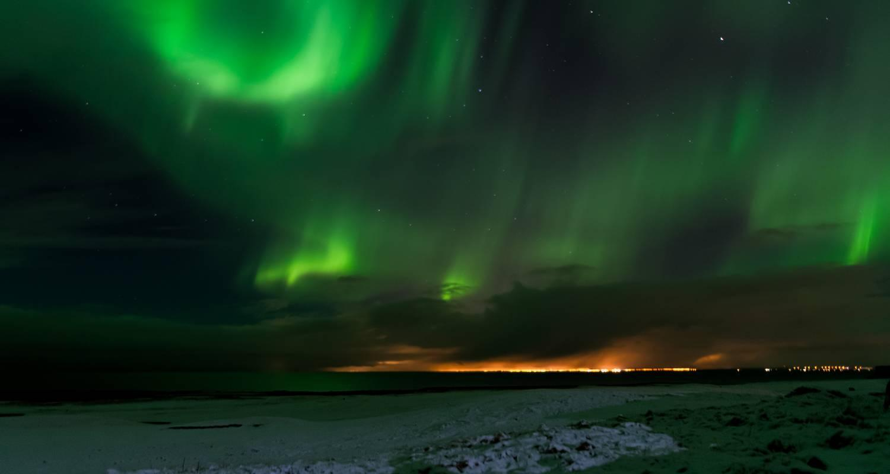



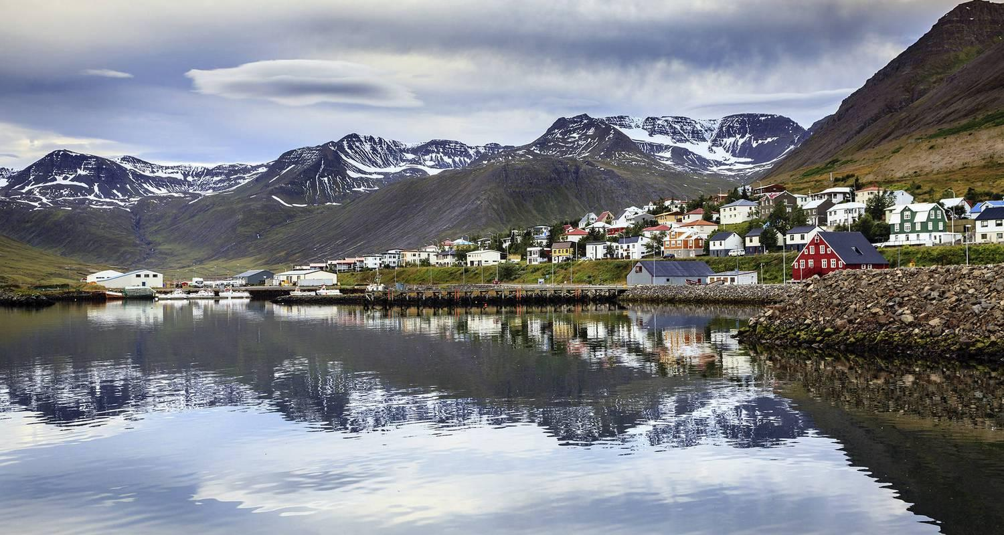

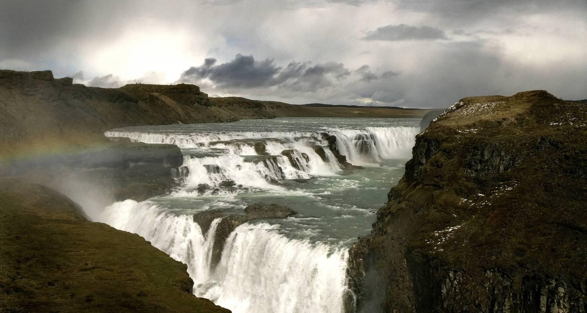

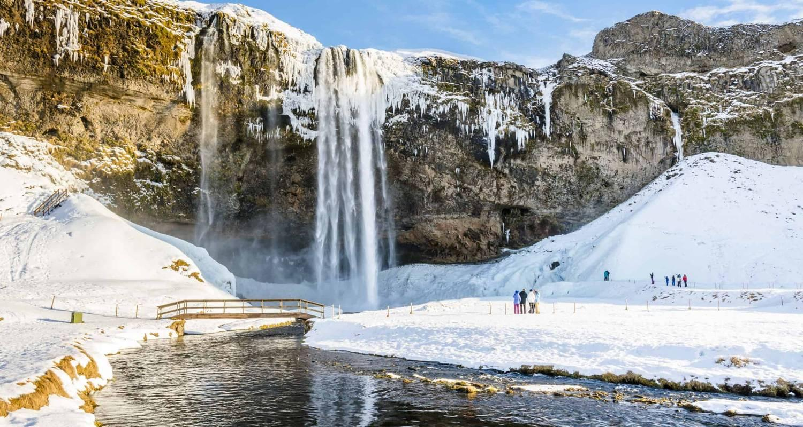

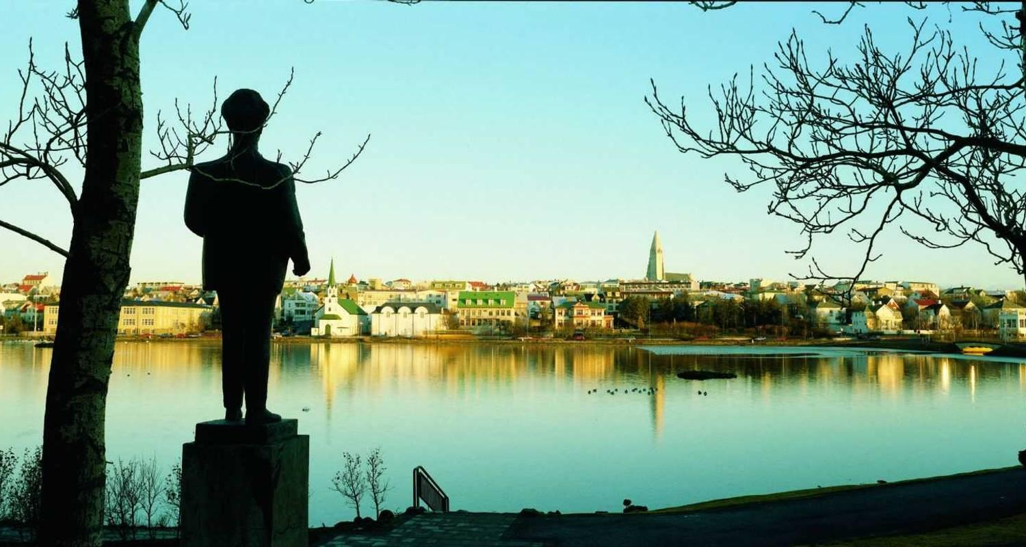

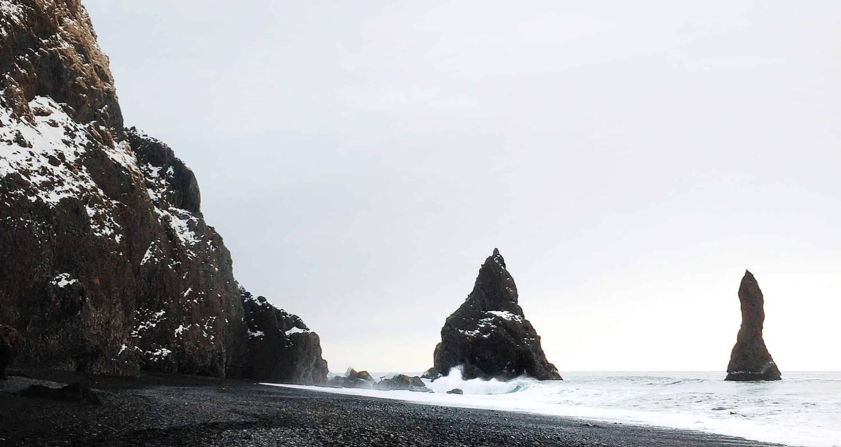

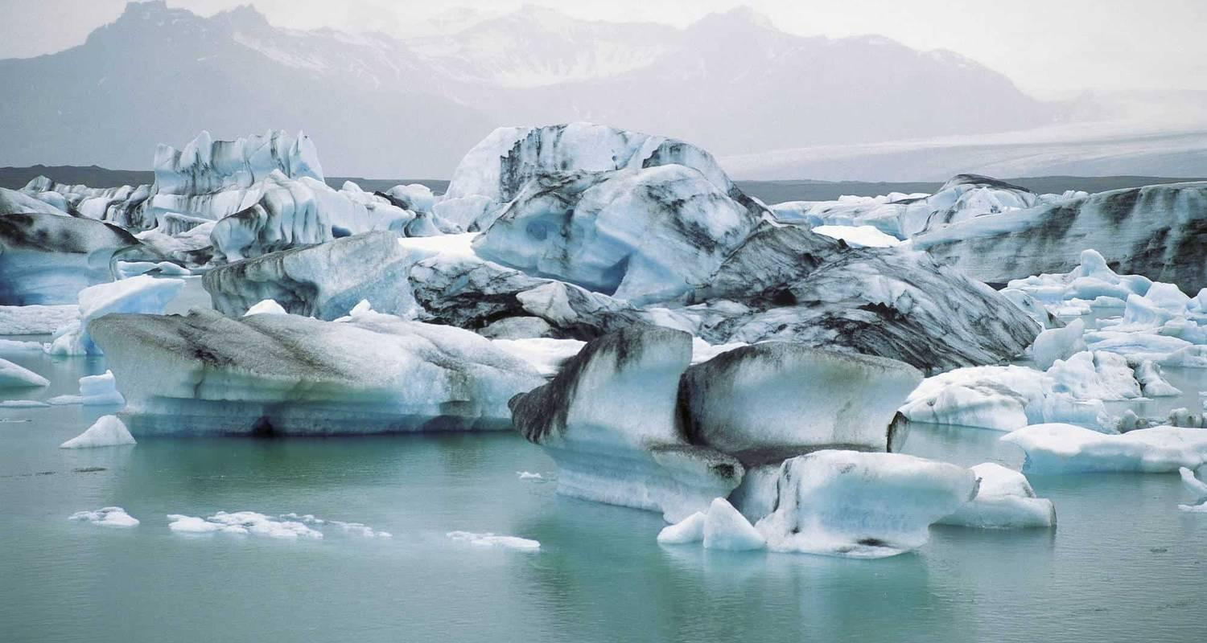

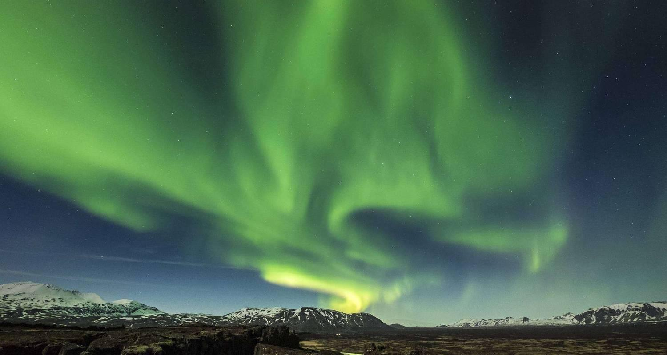

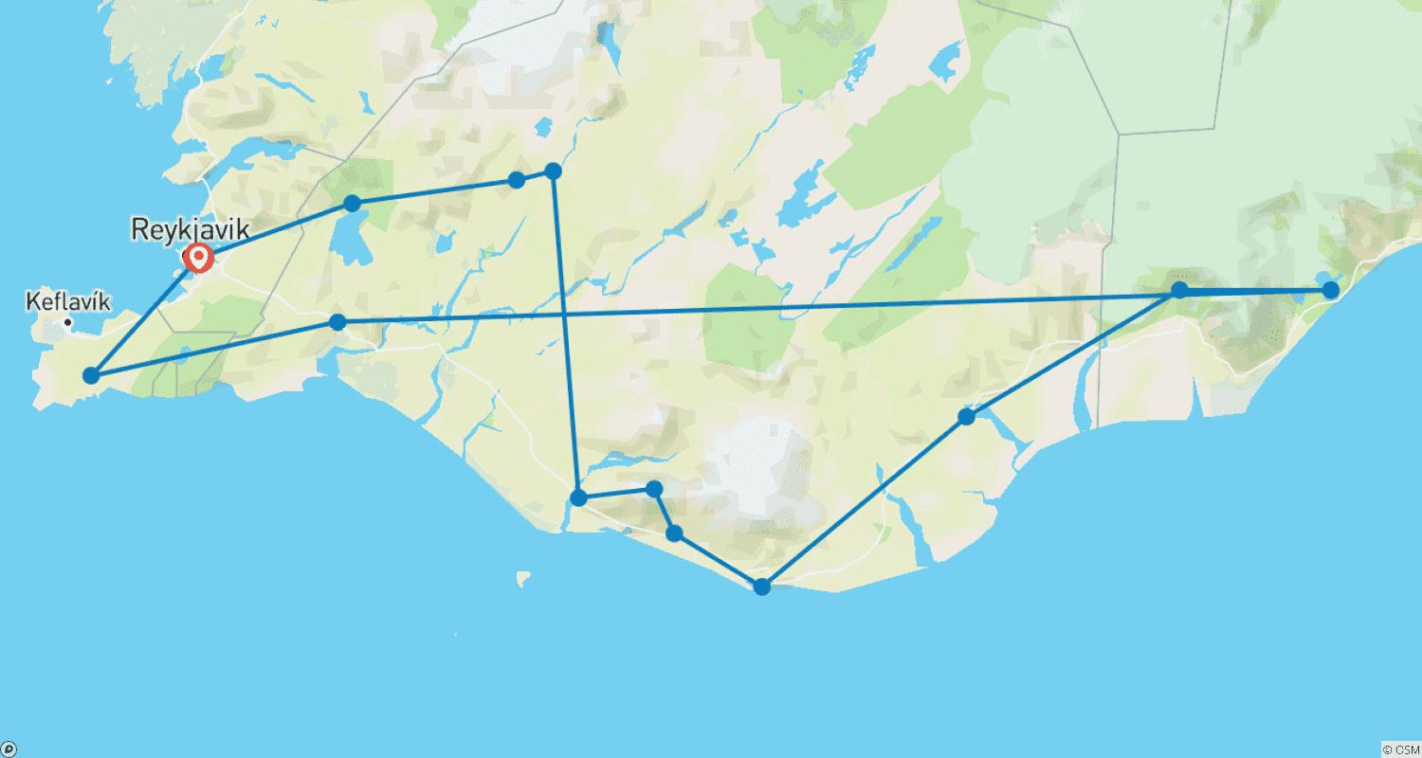

Tour ID: 101699  
Tour Name: Iceland & Greenland Discovery - 14 Days

Tour destinations: ['Keflavik', 'Reykjavik', 'Borgarnes', 'Grábrók Volcano', 'Akureyri', 'Godafoss', 'Myvatn', 'Hverfjall Volcano', 'Mount Namaskard', 'Dettifoss', 'Bakkagerdi', 'Egilsstadir', 'Stodvarfjordur', 'Djupivogur', 'Hofn', 'Jokulsarlon', 'Skaftafell', 'Kirkjubaejarklaustur', 'Vik', 'Reynisfjara', 'Skogafoss', 'Eyjafjallajokull', 'Seljaland', 'Geysir', 'Gullfoss', 'Thingvellir National Park', 'Ilulissat', 'Blue Lagoon']

Tour destinations images:

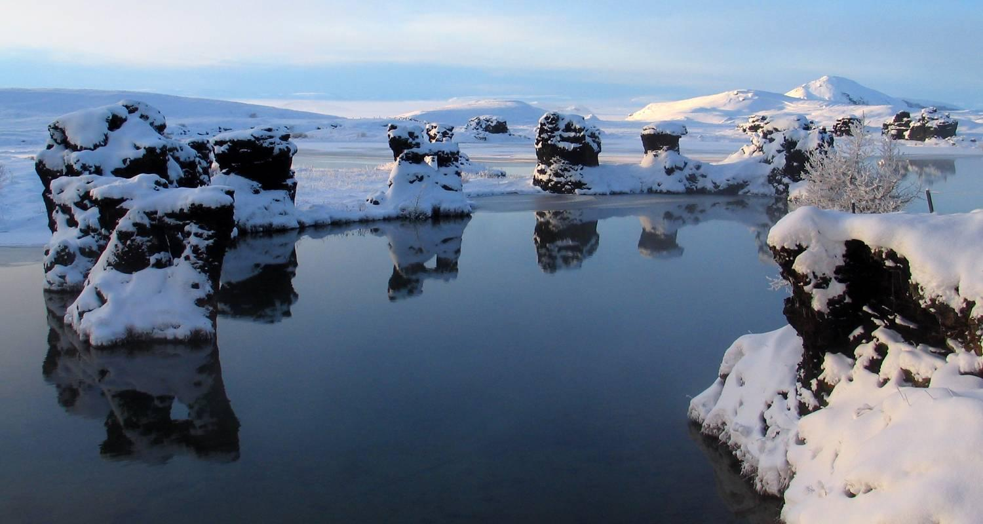

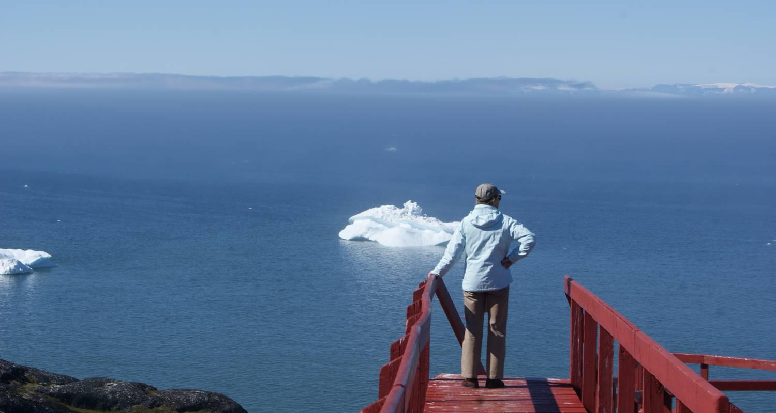

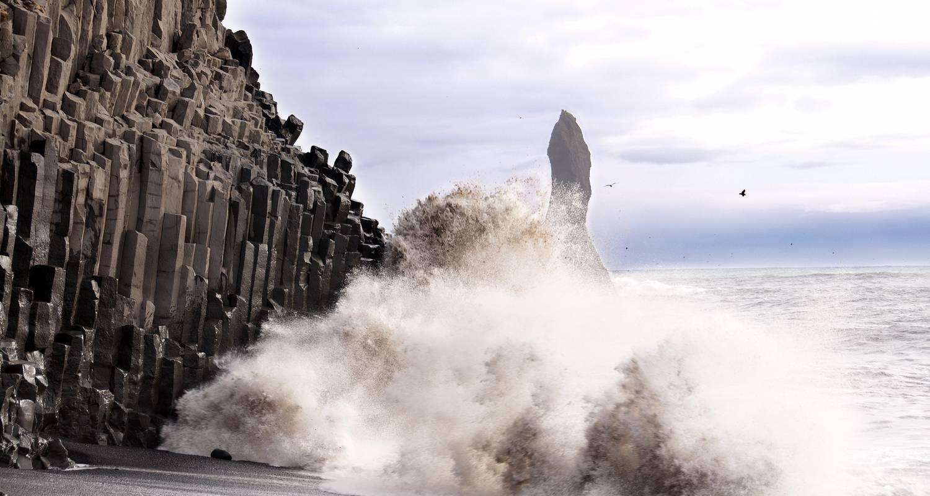

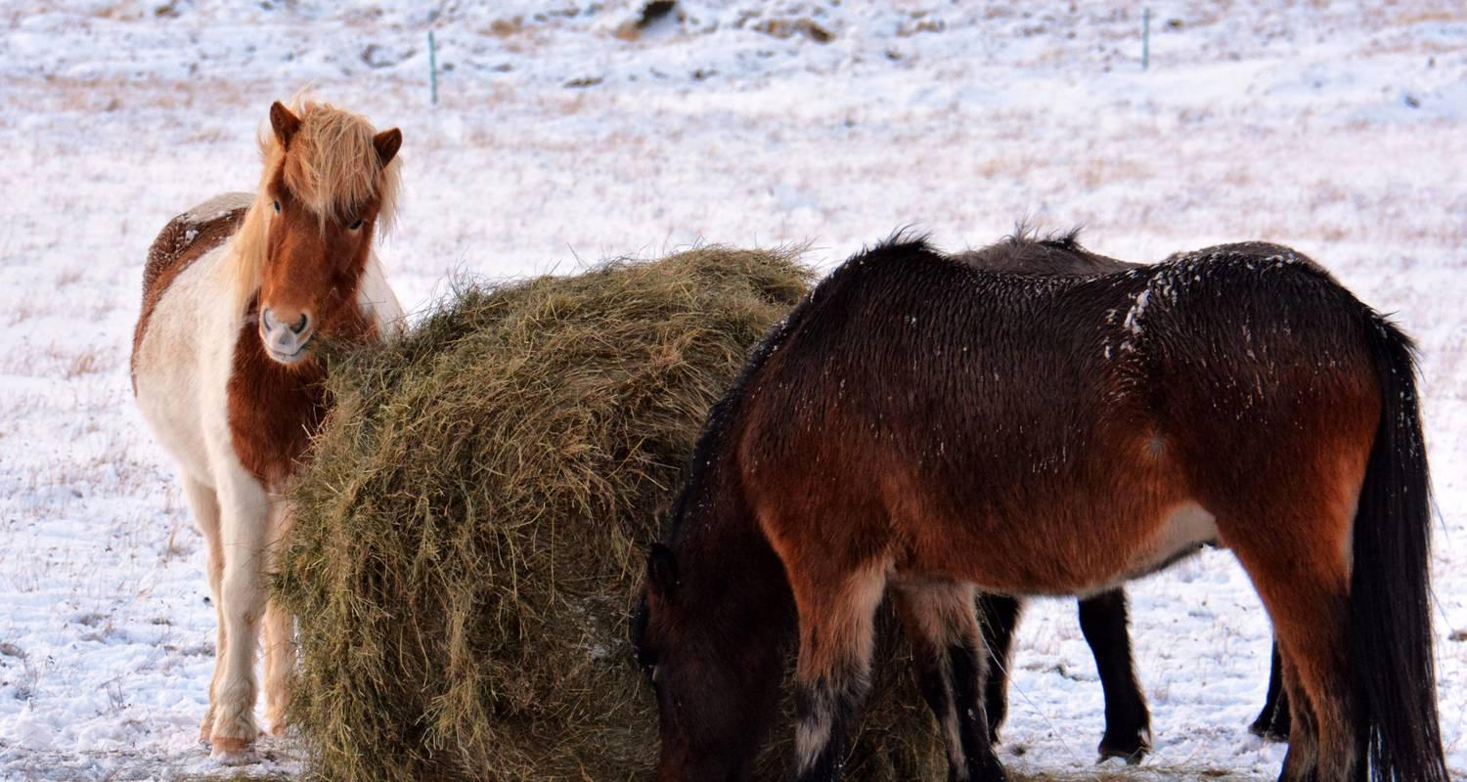

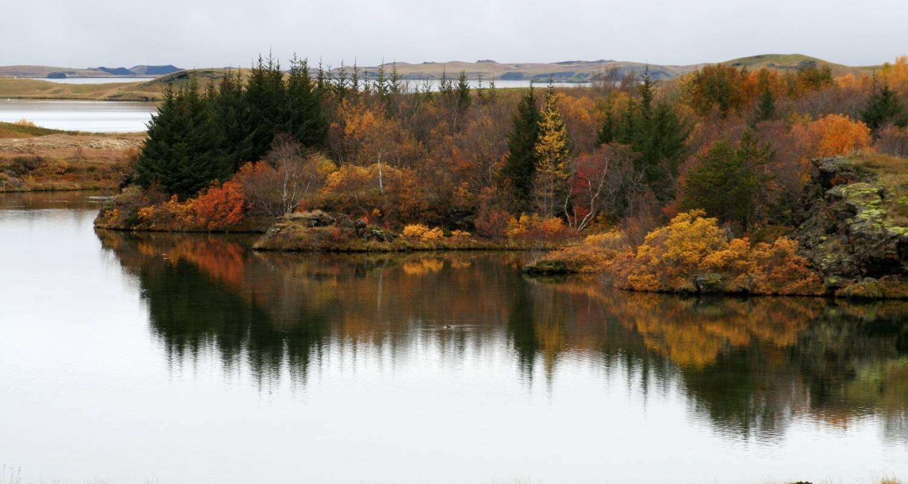

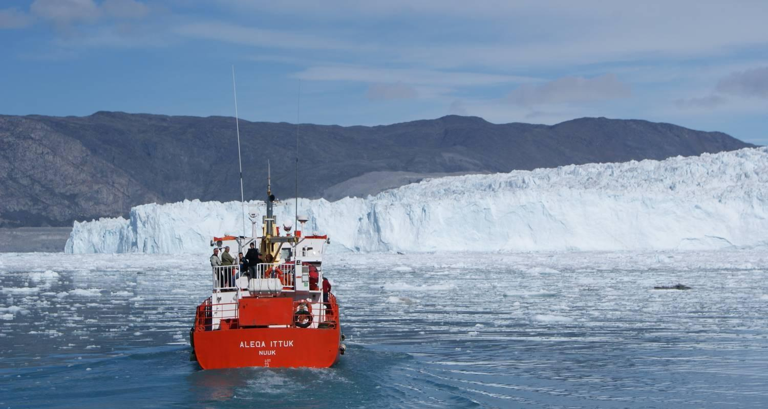

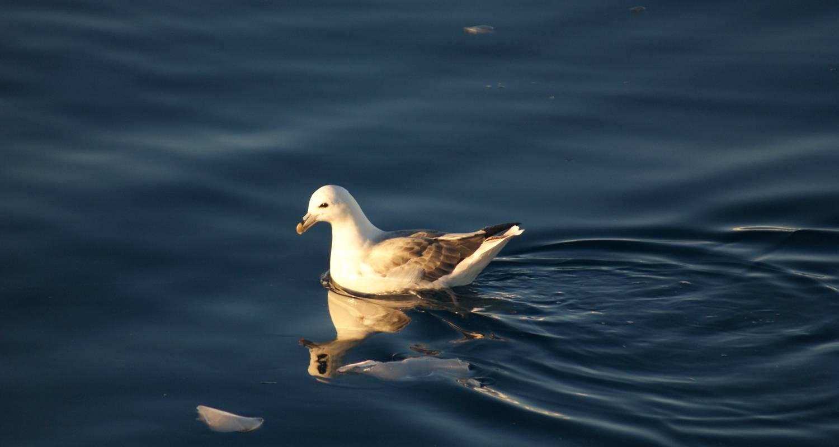

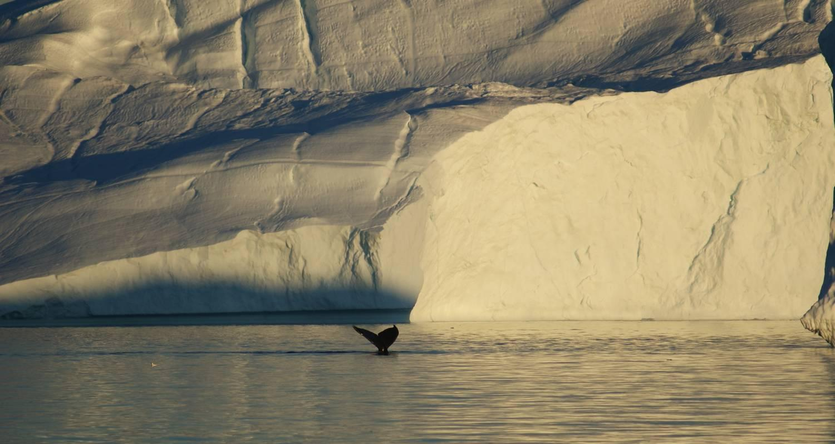

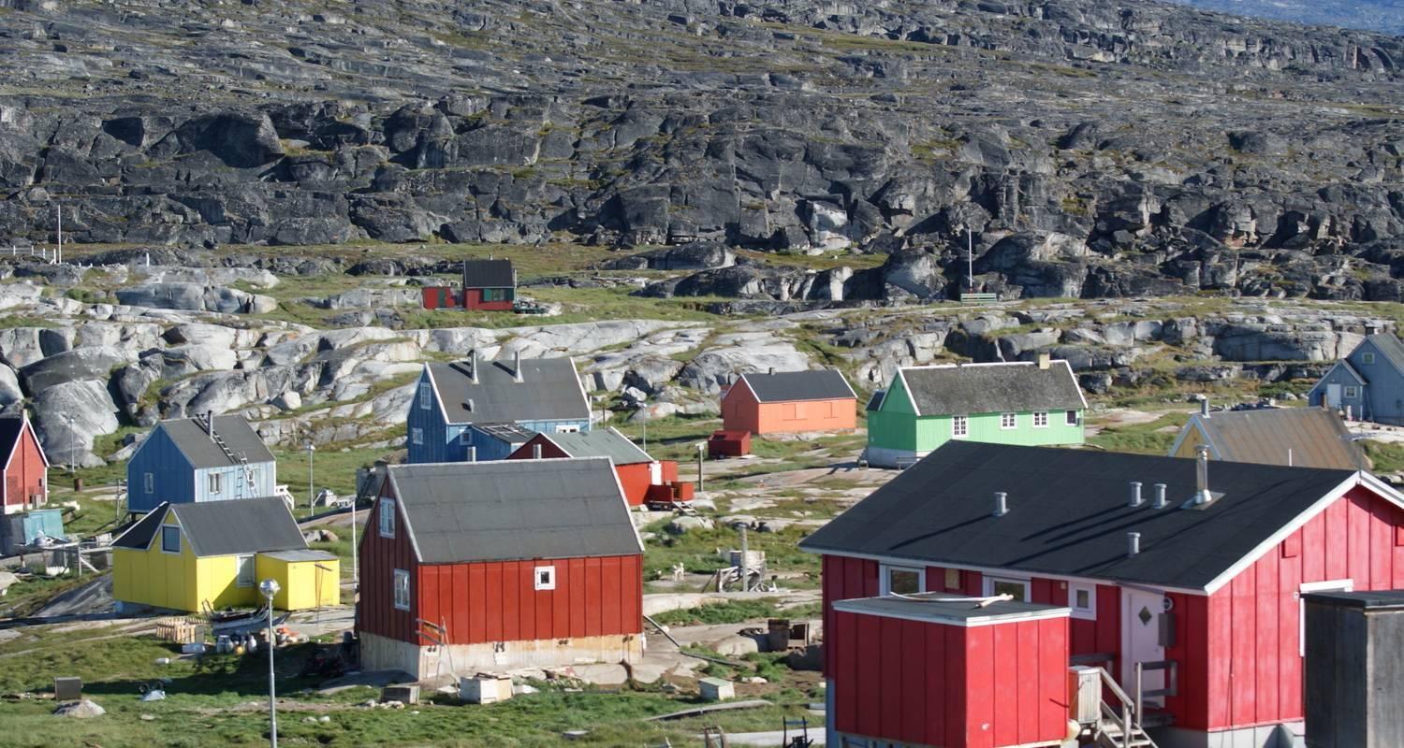

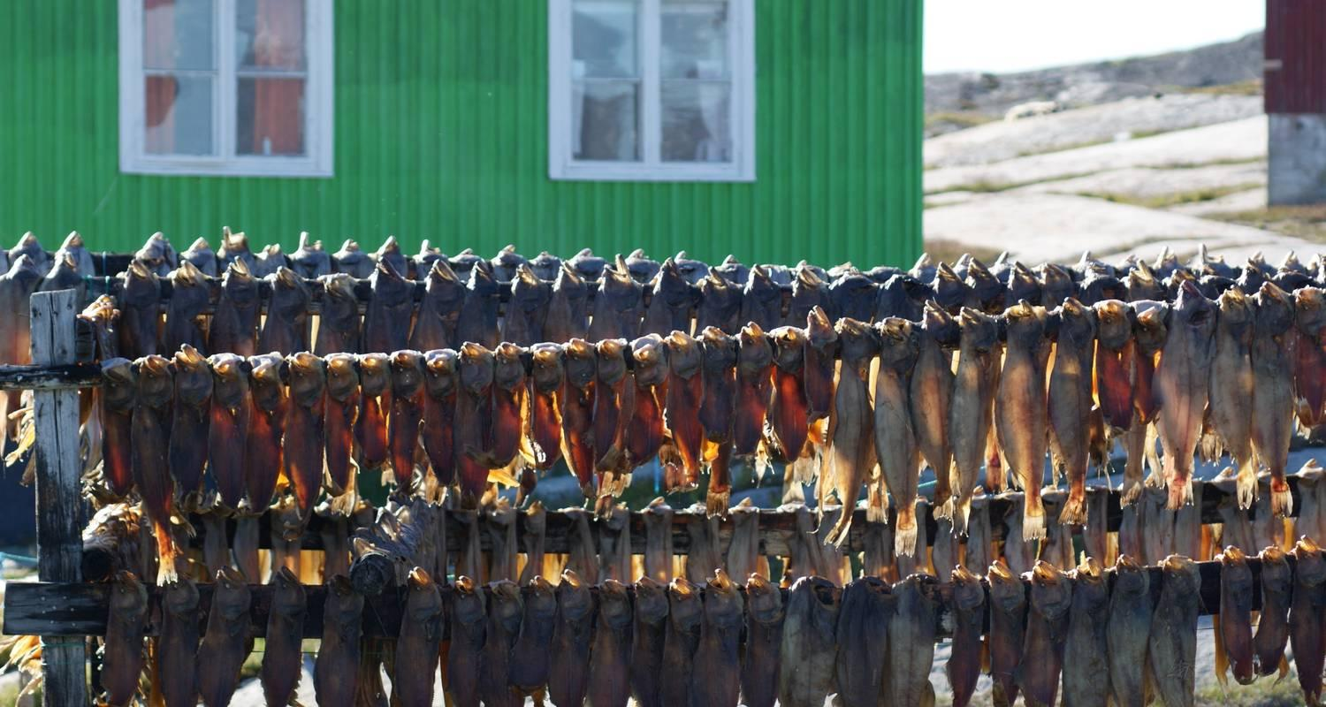

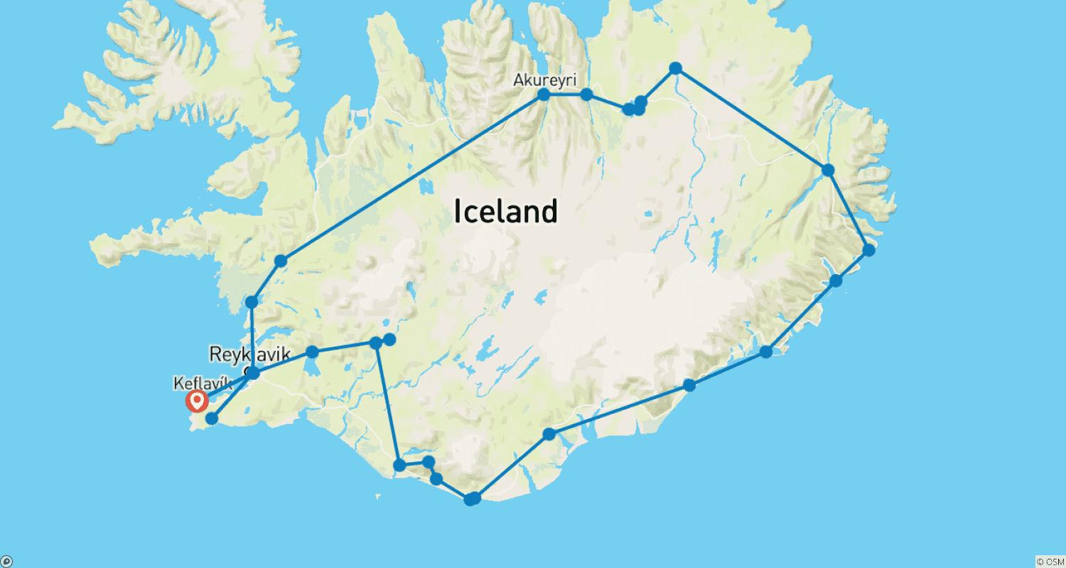

Tour ID: 101701  
Tour Name: Amazing Days in Ilulissat - 5 Days

Tour destinations: ['Keflavik', 'Ilulissat', 'Disko Bay']

Tour destinations images:

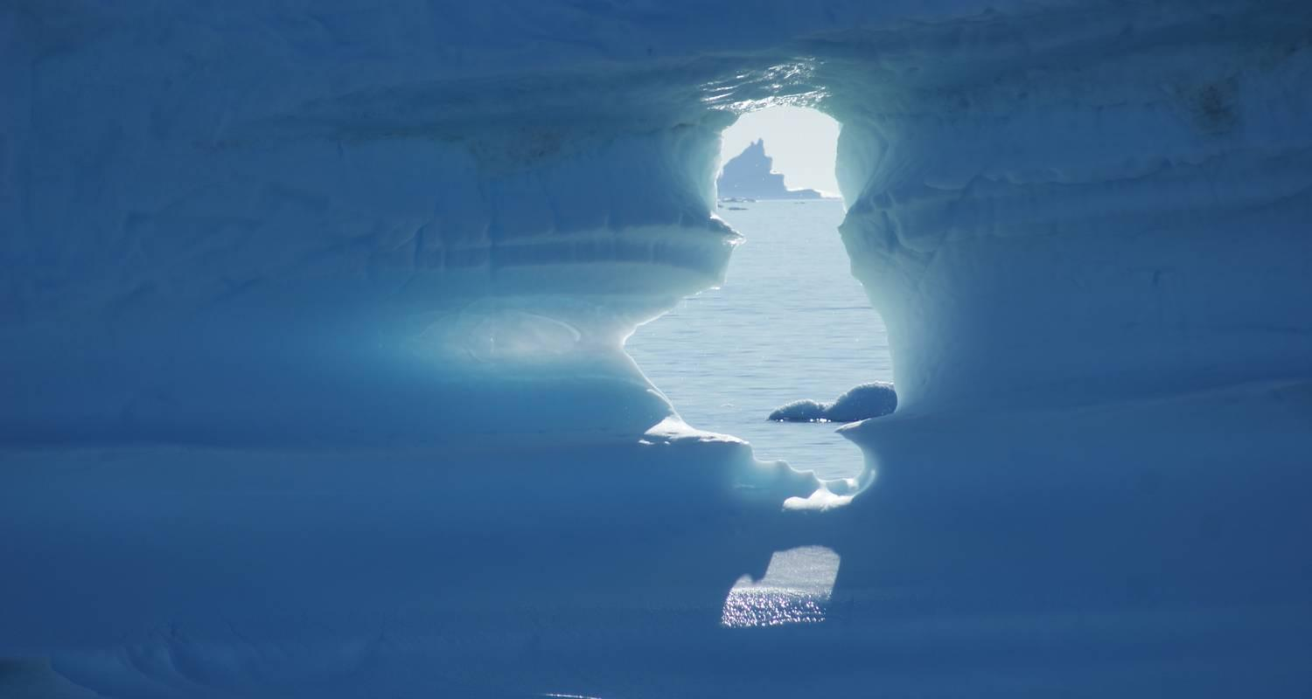

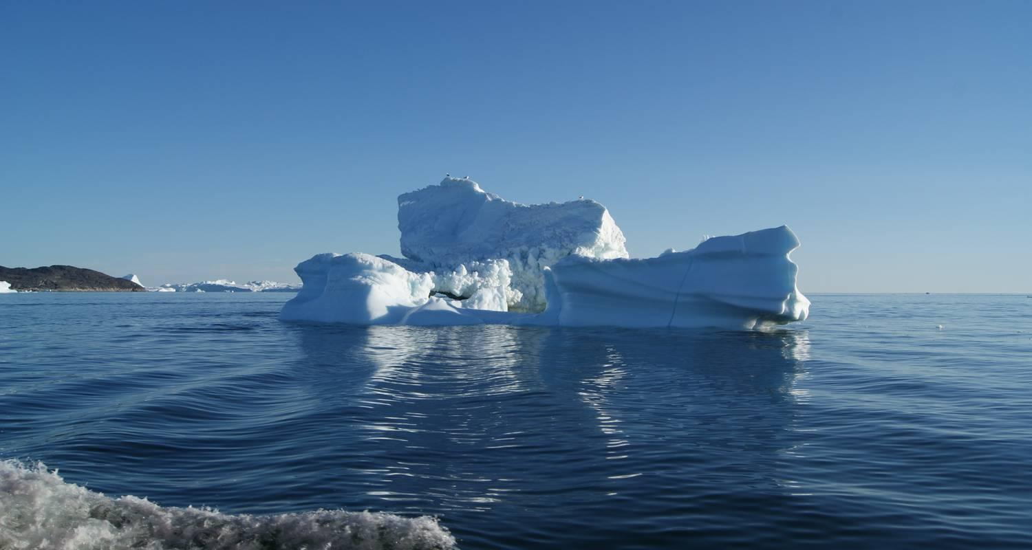

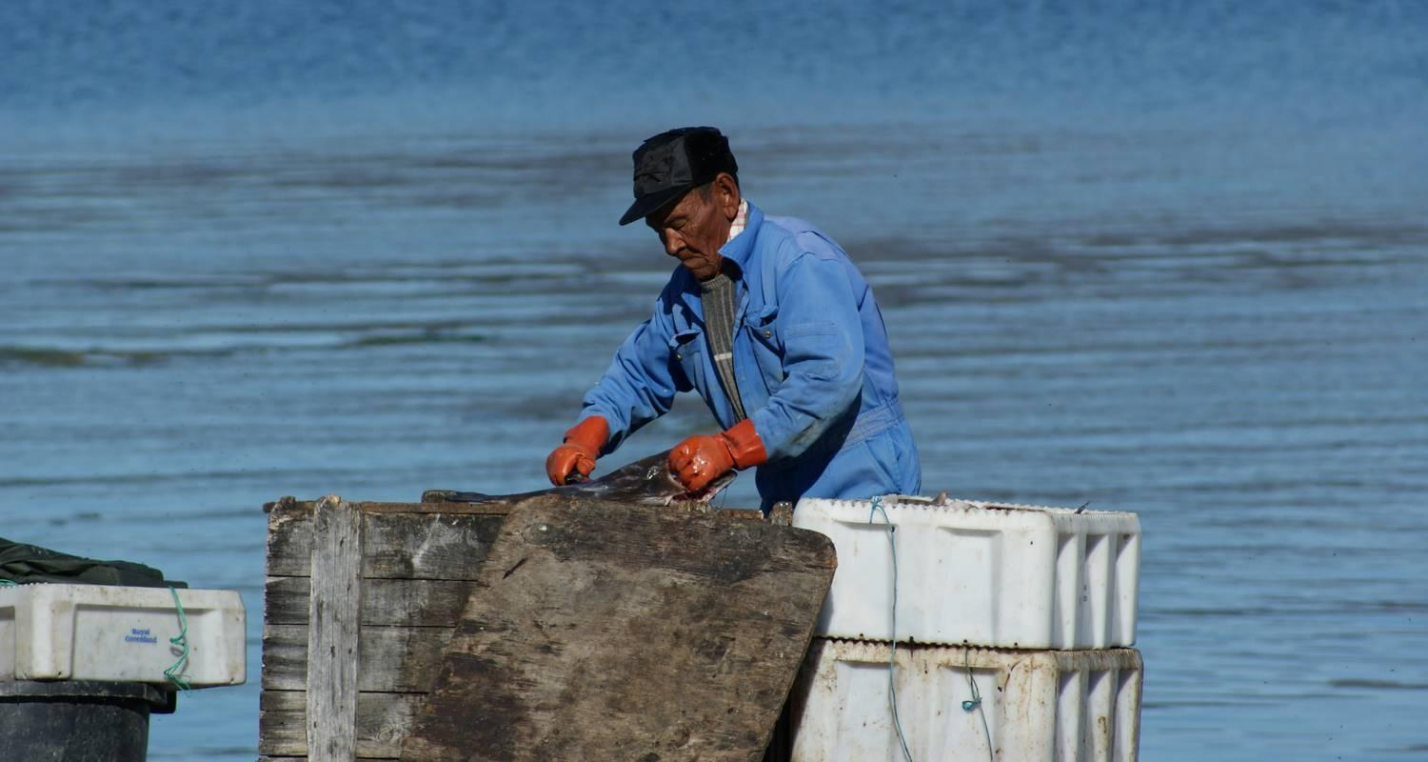

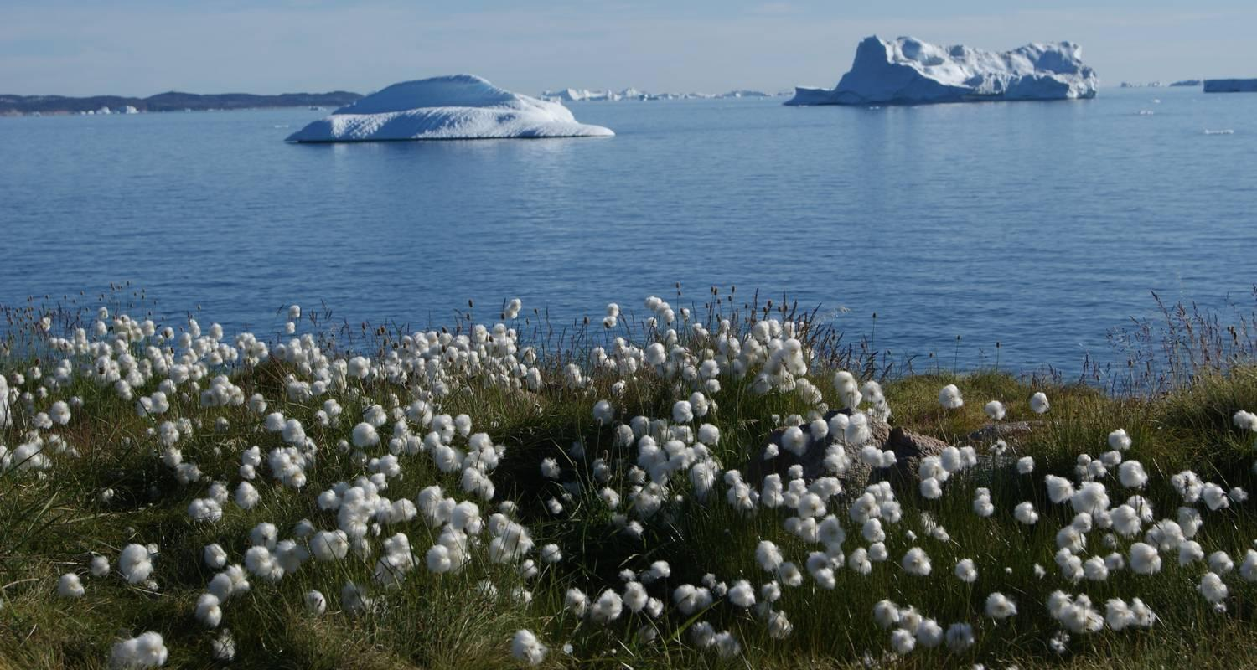



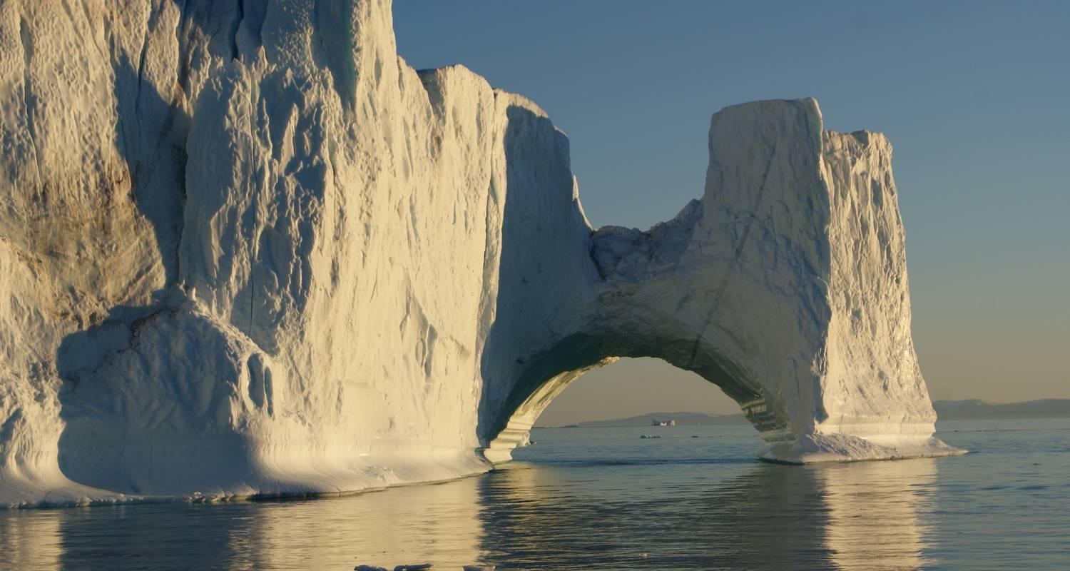

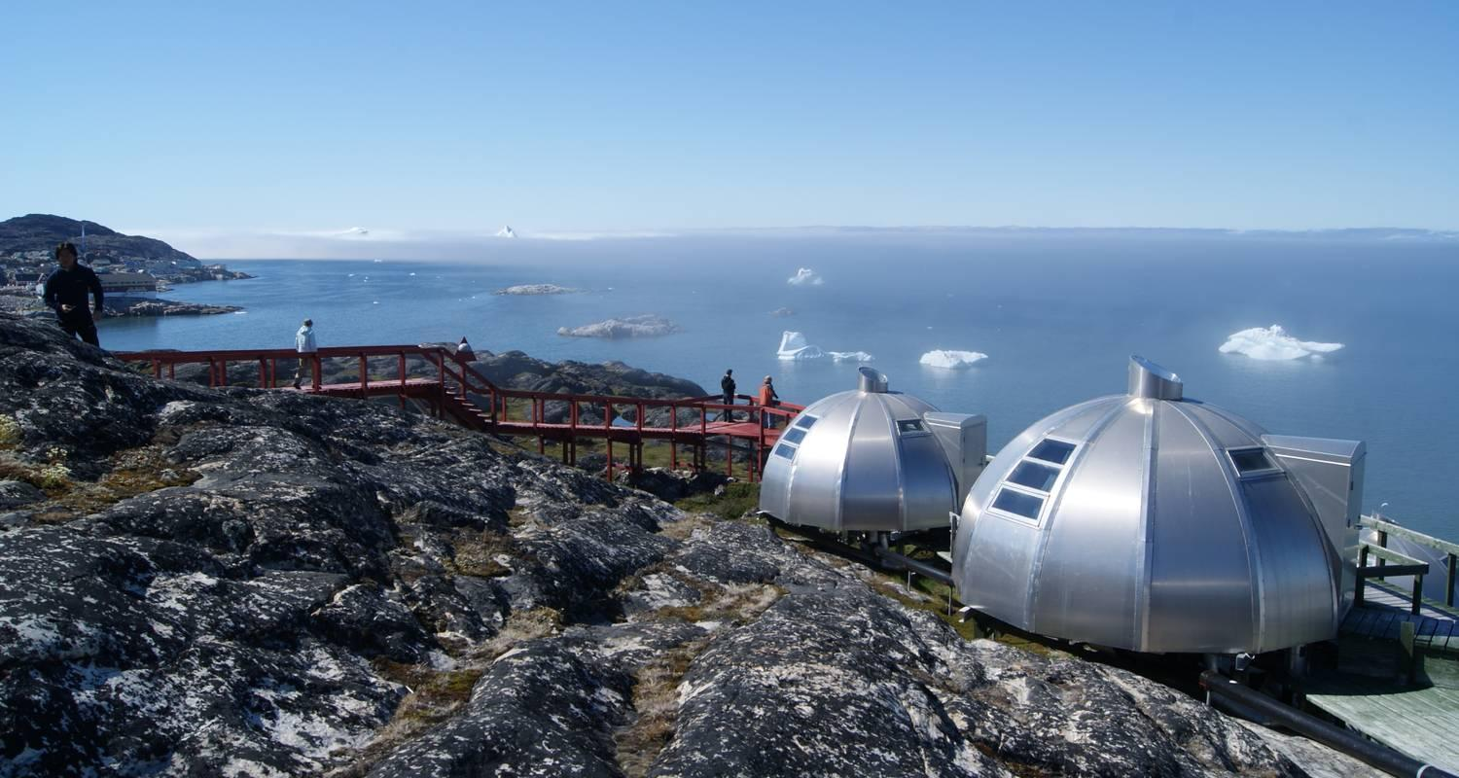

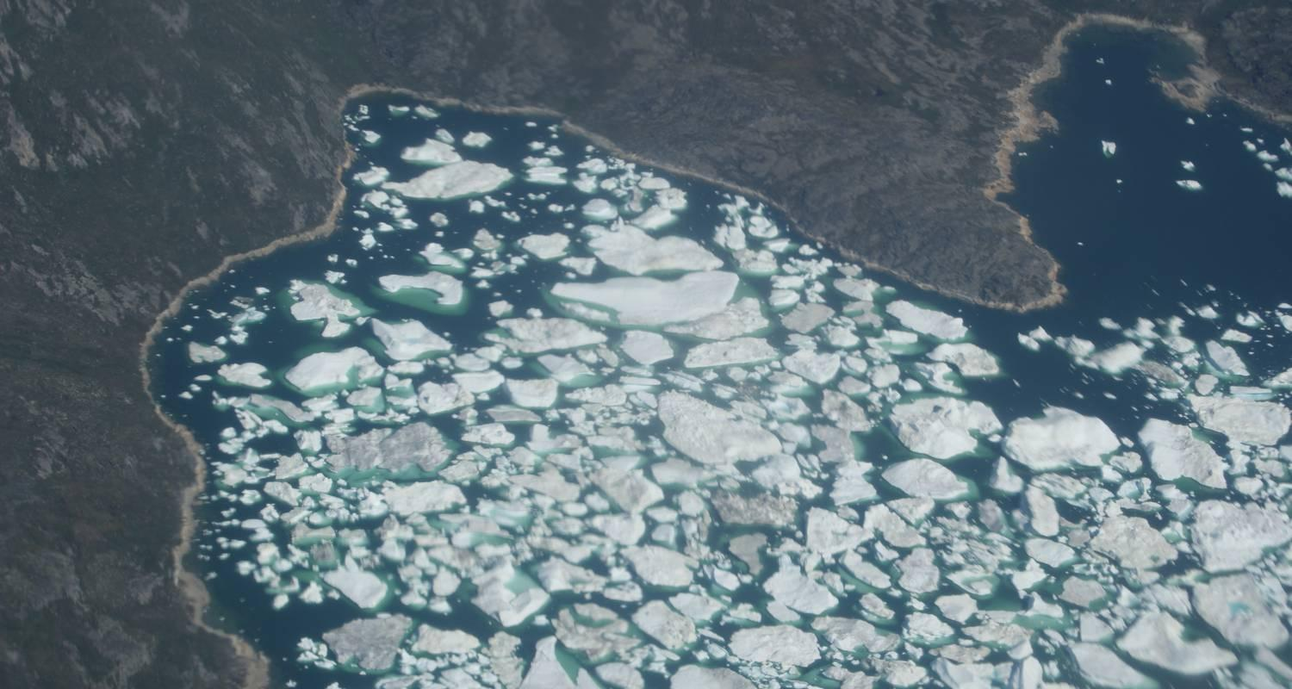

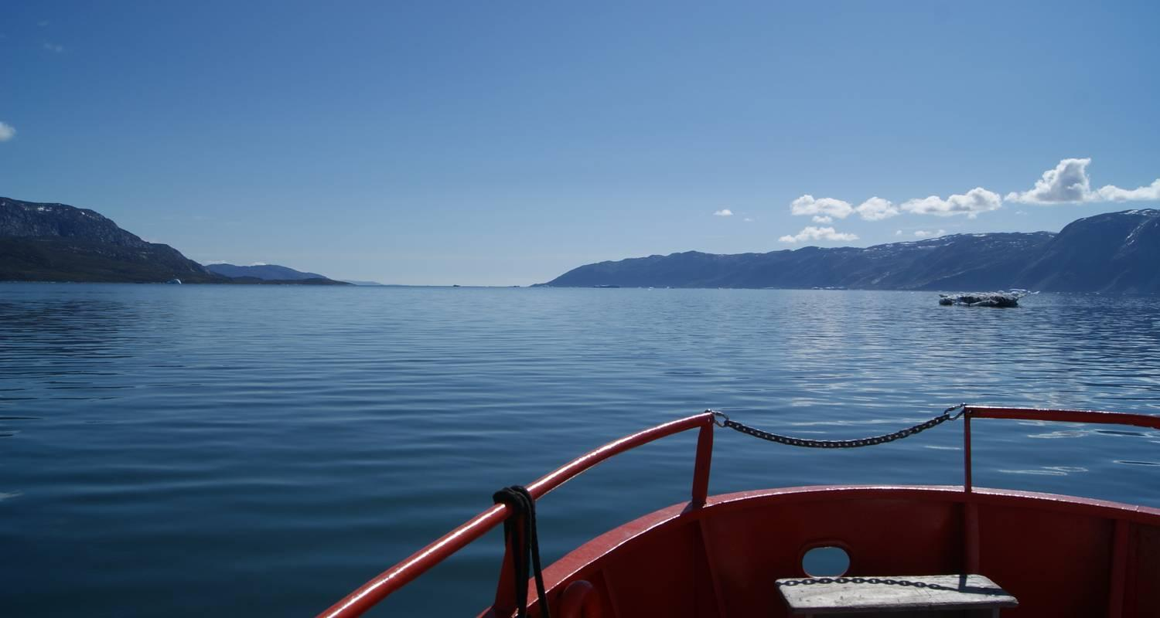



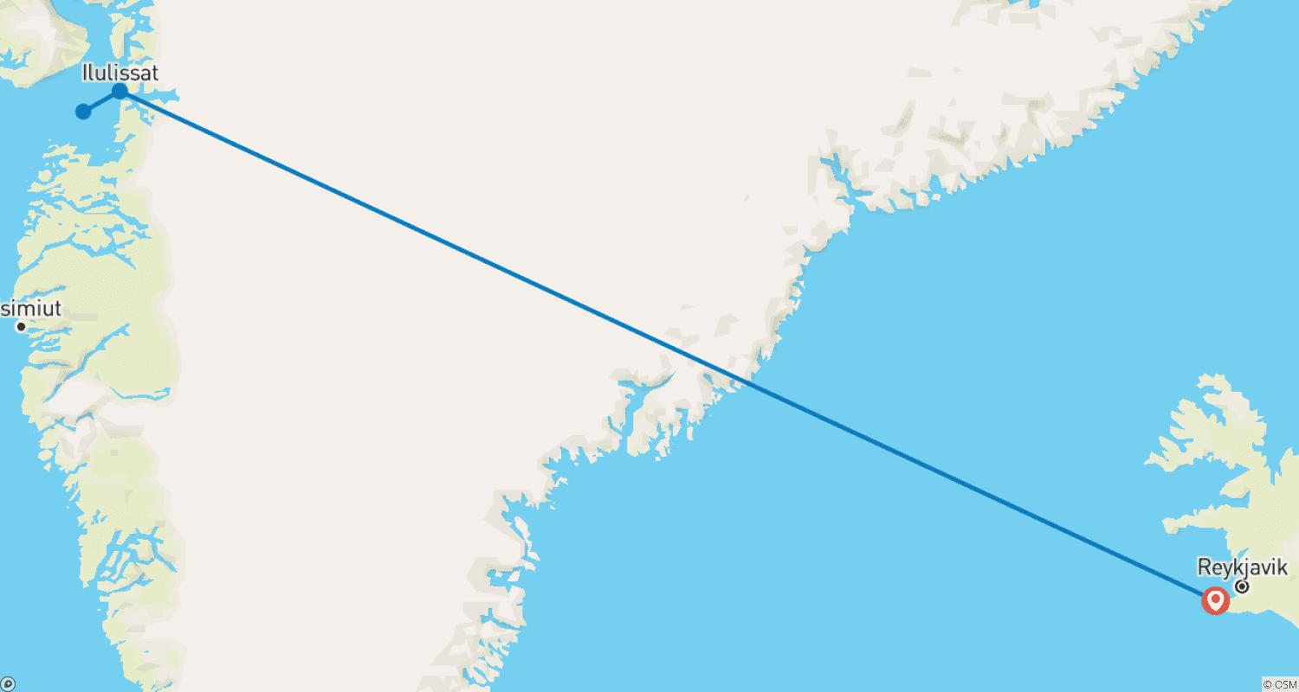

Tour ID: 101709  
Tour Name: Amazing Days in Ilulissat - 4 Days

Tour destinations: ['Keflavik', 'Ilulissat']

Tour destinations images:

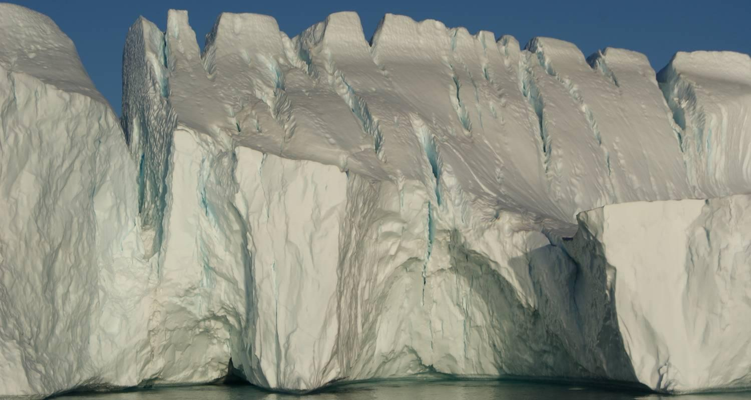



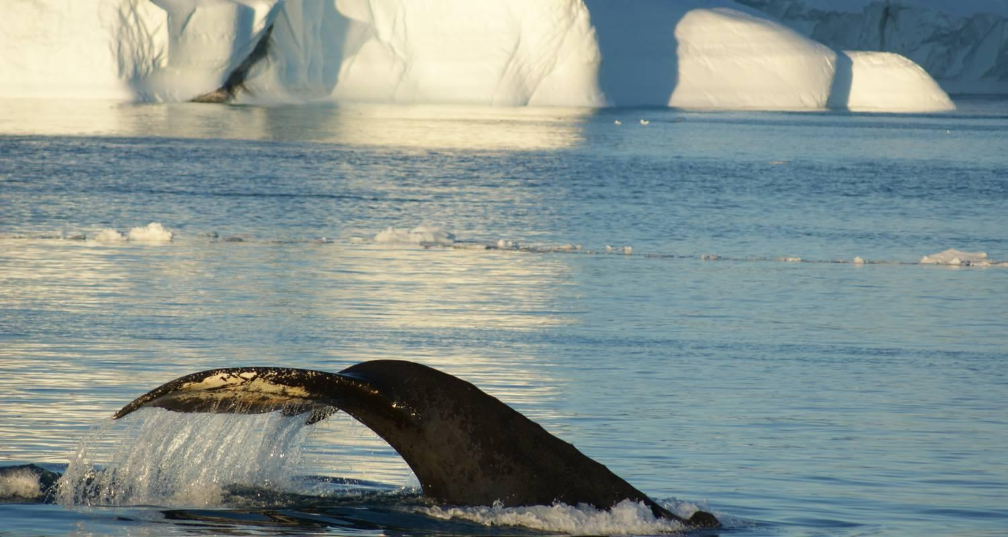

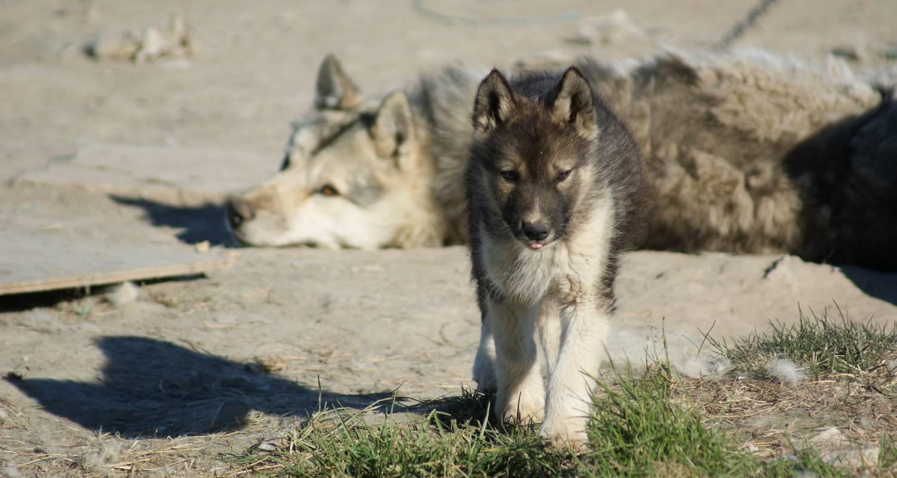





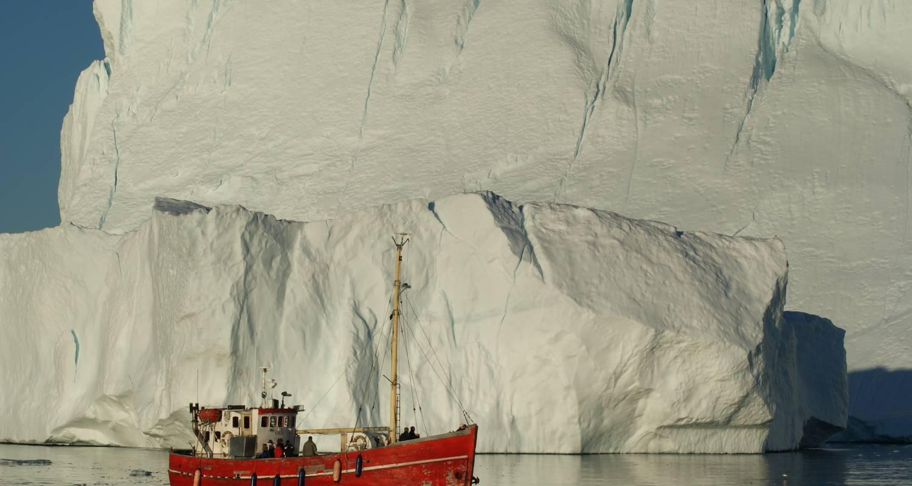

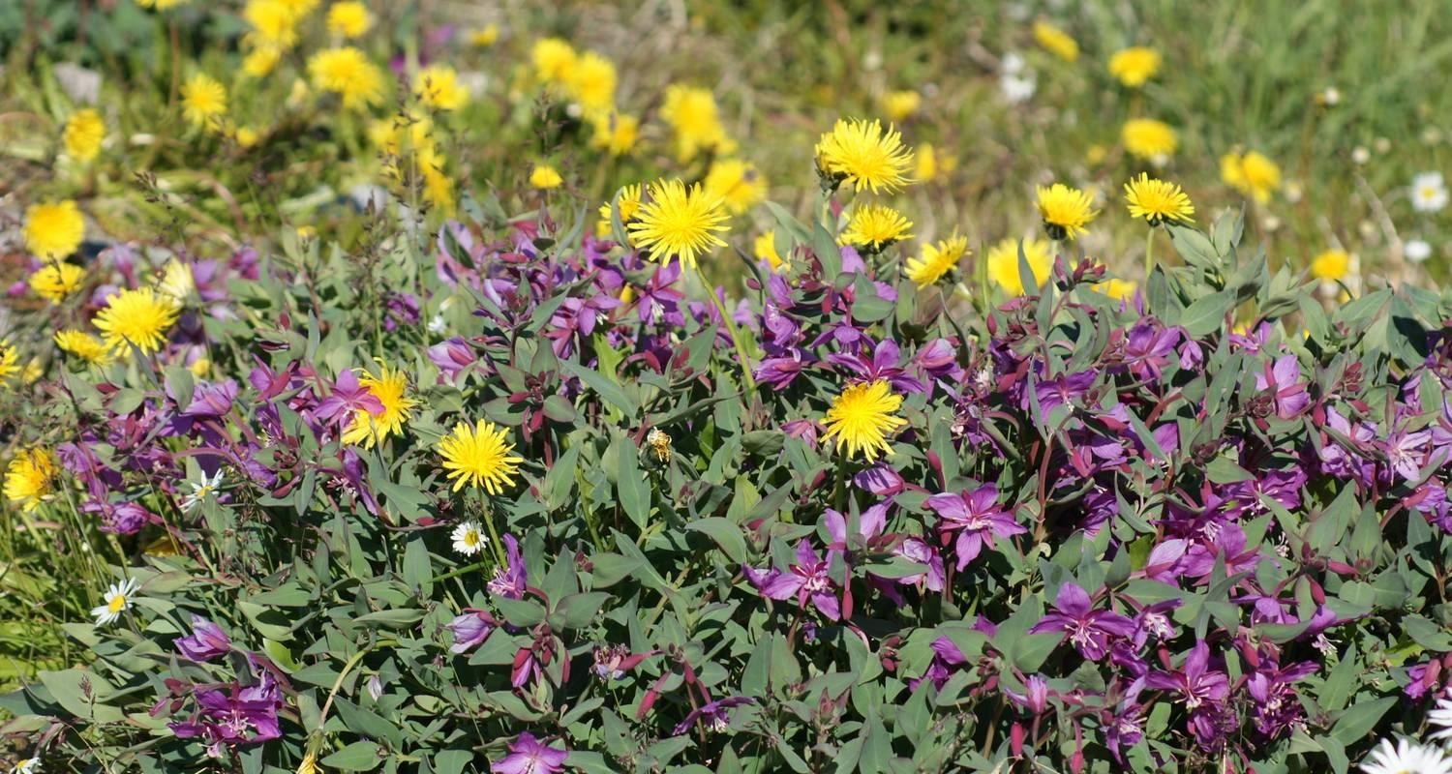

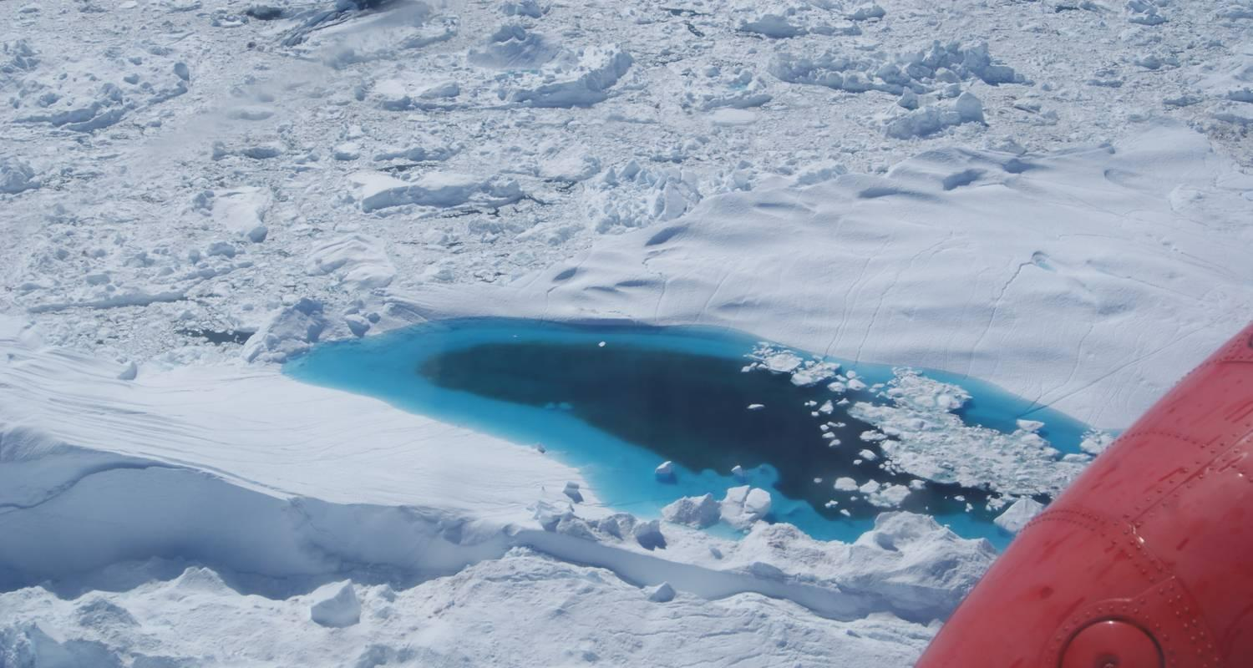

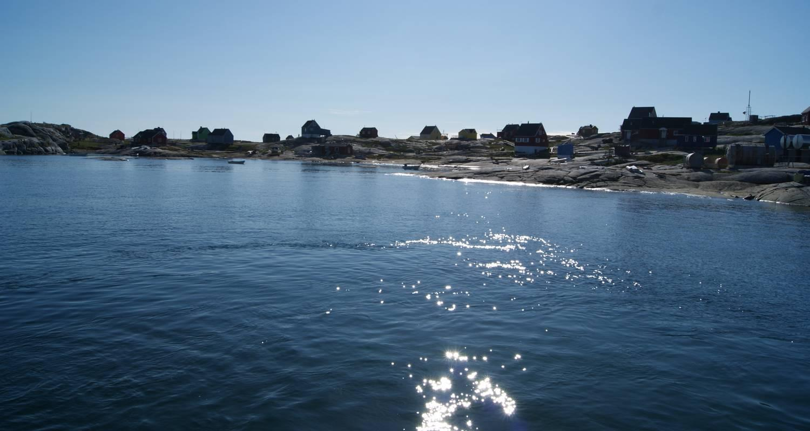

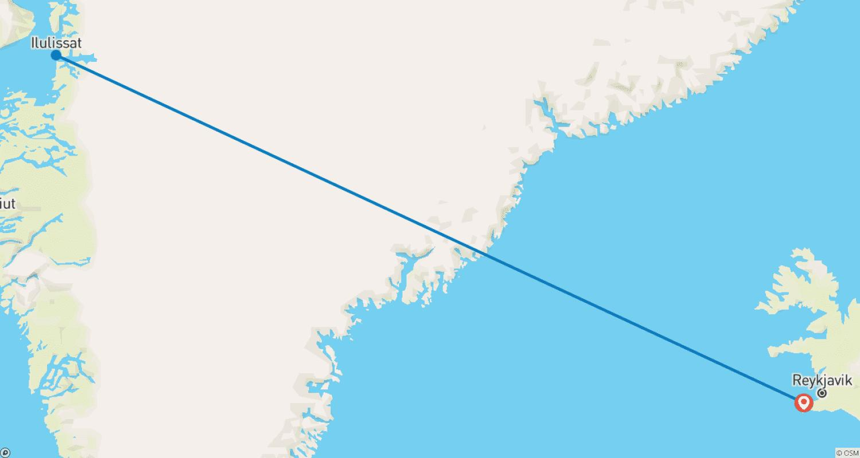

Tour ID: 104025  
Tour Name: 5 Days New Year's Festival

Tour destinations: ['Reykjavik', 'Thingvellir National Park', 'Geysir', 'Gullfoss', 'Reykjanesviti', 'Blue Lagoon']

Tour destinations images:

